## MicroMAX – a beamline with time-resolved macromolecular crystallography capabilities at the MAX IV Laboratory

### **D. Lang1, M. Bjelčić****1, M. Milas1, M. Chenchiliyan1, C.M. Casadei1, O. Aurelius1, I. Gorgisyan2, A. E. Jagudin1, M. Eguiraun1, A. Nardella1, E. Panepucci1, M. Malmgren1, S. Kapetanaki1, A. Gonzalez1, J. Nan1, and T. Ursby1**

### 1MAX IV Laboratory, Lund University, Fotongatan 2, 224 84 Lund, Sweden, 2European Spallation Source, Partikelgatan 2, 224 84 Lund, Sweden

### Presenting author: dean.lang@maxiv.lu.se

The rise of 4th generation sources, including the MAX IV Laboratory 3 GeV ring, has enabled new possibilities to study dynamics using crystallography. The MicroMAX beamline is a new beamline focussed on providing optimal X-ray characteristics for serial (SSX) and time-resolved (TR-SSX) crystallography at MAX IV [1]. The beamline emphasizes a flexible sample environment for standard and bespoke experimental setups while also supporting high-throughput single crystal data collections at the BioMAX beamline which has operated since 2017 [2].

The MicroMAX user program opened in May 2024 and has performed experiments with SPINE-based fixed targets, high-viscosity extrusion and microfluidics, single-crystal oscillation, and remote/automated data collections. Sample handling and positioning is supported by the MD3-up micro diffractometer, Oxford cryojet, and ISARA automated sample mounting platform (including crystallization plates). Time resolved techniques are enabled by a nanosecond pump laser (210-2600 nm), Celerotron X-ray chopper (0,8-70% duty cycle) and one of either an Eiger2 X 9M CdTe photon counting hybrid pixel detector or Jungfrau 9M Si integrating hybrid pixel detector (on-loan from PSI).

Optical elements allow for a beamline flux from 1013 photons/s (0.1% bandwidth double crystal monochromator) to more than 1014 photons/s (1% bandwidth multilayer monochromator) with an optimal 1x1 μm beam focus using beryllium lenses/K-B mirrors. Beamline controls are from within MXCuBE, with additional live feedback and CrystFEL autoprocessing pipelines to provide immediate feedback and rapid map generation. Sample pre-characterization is supported by an offline laser and spectroscopy lab in the secondary experimental hutch and dedicated sample environment and preparation labs.

Here we present the current status of MicroMAX beamline and recent developments in sample preparation and data handling under a variety of experimental contexts. This work emphasizes the technical developments for a highly flexible TR-SSX end station in context of SSX/TR-SSX experiments already being conducted by the MicroMAX user community.

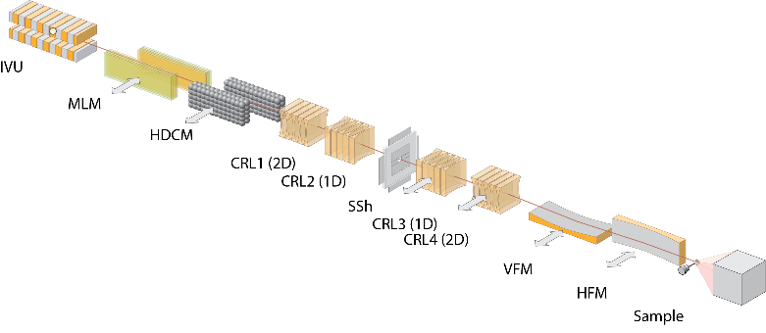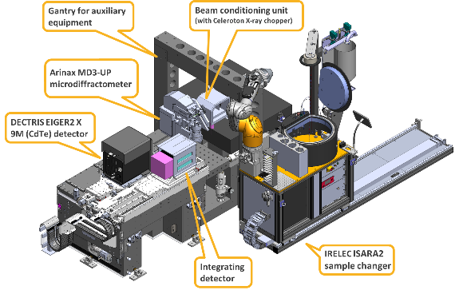

###### **Figure 1**. A schematic overview of the MicroMAX beamline optical components (left) and Experimental Hutch 1 endstation (right)

MicroMAX has been funded by the Novo Nordisk Foundation grant number NNF17CC0030666.

#### [*1*] Gonzalez, A., Krojer, T., Nan, J., Bjelcic, M., Aggarwal, S., Gorgisyan, I., Milas, M., Eguiraun, M., Casadei, C., Chenchiliyan, M., Jurgilaitis, A., Kroon, D., Ahn, B., Ekstrom, J. C., Aurelius, O., Lang, D., Ursby, T. & Thunnissen, M. M. G. M. (2025). J. Synchrotron Rad. 32.

#### [2] Shilova, A., Lebrette, H., Aurelius, O., Nan, J., Welin, M., Kovacic, R., Ghosh, S., Safari, C., Friel, R. J., Milas, M., Matej, Z., Högbom, M., Brändén, G., Kloos, M., Shoeman, R. L., Doak, B., Ursby, T., Håkansson, M., Logan, D. T. & Mueller U. (2020). J. Synchrotron Rad., 27, 1095.