# Searching for the hidden phases of Fe(II) metal-organic SCO frameworks

## E. Trzop,1,2 R. G. Torres-Ramirez,1 F. J. Valverde-Muñoz,1 E. Collet,1,2 M. C. Muñoz,3 D. Zhang,4 J. A. Real,5

### 1 Institute de Physique de Rennes, Université de Rennes. UMR CNRS 6251, 35000 Rennes (France), 2 CNRS, Univ Rennes, DYNACOM– IRL 2015, The University of Tokyo, Tokyo (Japan), 3 Departamento de Física Aplicada, Universitat Politècnica de Valencia. 46022 Valencia (Spain), 4 College of Chemical Engineering, Shandong University of Technology. 255049 Zibo (China), 5 Instituto de Ciencia Molecular, Universitat de València. 46980 Paterna (Spain).

### Email: elzbieta.trzop@univ-rennes.fr

Multistable molecular materials present changes of electronic states linked to a spin transition and/or charge transfer around transition metals making these materials multi-functional, i.e., ferromagnetic, ferroelastic and/or or ferroelectric. For technological applications, it is essential to understand how the different phases coexist and, at the same time, to identify proper external stimuli (e.g., temperature, pressure, light or even, much less-explored, magnetic or electric fields) that allows for selective and controlled conversion between these different phases [1-7].

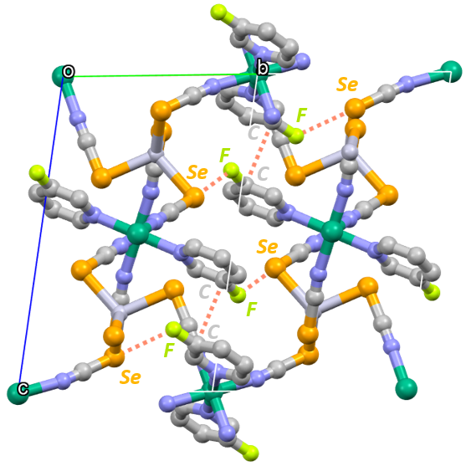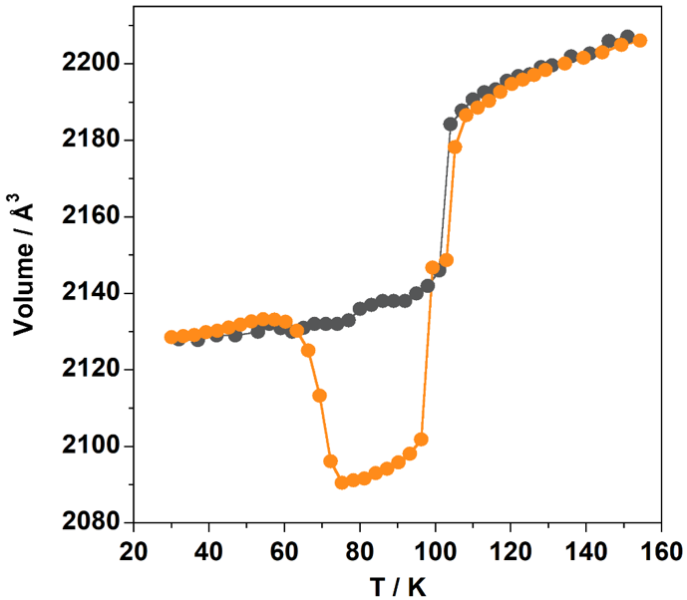

###### **Figure 1**. Structure representation (*left*) and temperature variation of a crystal cell volume (*right*) for {FeII(3Fpy)2[HgII(SeCN)4]}.

Here I focus on a novel tri-dimensional Fe(II) spin-crossover coordination polymer of {FeII(3Fpy)2[HgII(SeCN)4]} (*Fig. 1. left)*. This complex shows an interesting and unconventional multi-stability with a number of hidden states accessible by change of the temperature down to 30K (*Fig. 1. right*) and/or photo-excitation. Magnetic measurements in combination with an advanced structural analysis of a single crystal X-Ray diffraction data reveal the importance of the interplay between the spin state switching and the change of symmetry in the generation of different phases.

#### References:

#### [1] Y. Otsuki, S. Kimura, S. Awaji & M. Nakano, (2019). AIP Advances, **9**, 085219.

#### [2] A. Bousseksou, G. Molnár & G. Matouzenko, (2004). Eur. J. Inorg. Chem., 4353- 4369.

#### [3] E. Trzop, et al., (2016). Angew. Chem. Int. Ed. **55**, 8675–8679.

#### [4] D.-P. Zhang, et al., (2017). Crystal Growth & Design, **17** (5), 2736-2745.

#### [5] L. Piñeiro-López, et al., (2021). Chem. Science **12**, 1317- 1326.

#### [6] V.B. Jakobsen, et al., (2020). Angew. Chem. Int. Ed. **59**, 13305-13312.

#### [7] V. B. Jakobsen, et al., (2021). Inorg. Chem., **60** (9), 6167-6175.

Acknowledgements: F. J. Valverde-Muñoz thanks to the European Union’s Horizon 2020 research and innovation programme for founding under the Marie Skłodowska-Curie grant agreement No 899546.