# Streaming crystallography and Landau theory on the study of the out-of-equilibrium photo-induced phase transition in a RbMnFe Prussian Blue Analogue

## R. G. Torres Ramírez1,2, M. Hervé1,2, G. Privault1,2, E. Trzop1,2, S. Akagi3, Y. Watier4, S. Zerdane5, I. Chaban1,2, C. Mariette1,4, A. Volte4, M. Cammarata4, M. Levantino4, H. Tokoro3,2, S. Ohkoshi6,2, E. Collet1,2,7

### 1Univ Rennes, CNRS, IPR (Institut de Physique de Rennes) - UMR 6251, 35000 Rennes, France, 2DYNACOM IRL2015 Univ. of Tokyo-CNRS-UR1, Dept. of Chemistry, 7-3-1 Hongo, Tokyo 113-0033, Japan, 3Dept. of Materials Science, Faculty of Pure and Applied Sciences, Univ. Tsukuba, Tsukuba, 305-8577, Japan, 4ESRF – The European Synchrotron, 71 avenue des Martyrs, CS40220, 38043 Grenoble Cedex 9, France, 5SwissFEL, Paul Scherrer Institut, Villigen, PSI, Switzerland, 6Dept. of Chemistry, School of Science, The University of Tokyo, 7-3-1 Hongo, Tokyo 113-0033, Japan, 7Institut universitaire de France (IUF)

### ricardo-guillermo.torresramirez@univ-rennes.fr

*RbMnFe Prussian Blue Analogues* (PBA) are interesting materials for their reported thermal and photo-induced switching of macroscopic properties.[1] With a wide thermal hysteresis of about 73 K centred at room temperature, together with their single laser pulse ultrafast switching between long-lived photo-induced states (Figure 1), they represent a promising material for the development of novel, robust, and more efficient light-based technologies. Upon excitation, these materials undergo an *intermetallic charge transfer (CT)* and an associated *symmetry-breaking (SB),* transforming from a tetragonal Mn(III)Fe(II) phase to a cubic Mn(II)Fe(III) phase. It has been theoretically proven that the *elastic coupling* between these phenomena is at the origin of its wide thermal hysteresis.[2] However, for a better control of the switching process and therefore, of the macroscopic properties, it is crucial to understand the dynamics involved, which can only be done with time-resolved techniques.

In this work, we present our experimental studies and, foremost, their theoretical interpretation on the out-of-equilibrium photo-conversion, within the thermal hysteresis, of a Co-doped RbMnFe PBA derivative (Figure 1a).[3] Given the persistent photo-induced states of our sample, the study of its structural dynamics was done with a time-resolved *streaming crystallography* technique.[4] Our experimental results evidence a *laser excitation fluence threshold* in the photo-conversion. Above this threshold, the system globally switches to the persistent Mn(II)Fe(III) cubic phase within 100 ps. Below this threshold, the initial tetragonal Mn(III)Fe(II) phase exhibits structural distortions due to the formation of less bonding Mn(II)Fe(III) CT polarons, but it then relaxes back to the tetragonal ground state in about 10 µs. It is the interplay between *elastic interactions* that drives the photo-conversion, with the *volume strain* having a prominent role, as also interpreted by a symmetry-adapted *Landau-based model* (Figure 1b). Here, we focus on the introduction to the fundamentals of this model, which describes the thermodynamic state of the system by the incorporation of both CT and SB processes, represented by corresponding order parameters, and coupled via their own association to the volume strain. Due to its simplicity, flexibility, and rigor, this model not only provides a solid interpretation of our experimental results, but can also be applied to the study of other systems undergoing phase transitions associated to changes of electronic state and symmetry-breaking.

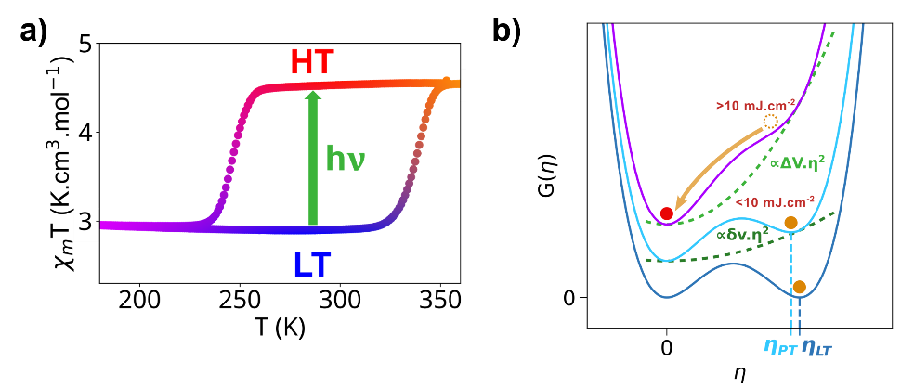

###### **Figure 1.** a)Scheme of photo-induced phase transition, within thermal hysteresis, of Co-doped RbMnFe PBA. b) Landau-based model calculated thermodynamic potentials with respect to symmetry-breaking order parameter $η$ ( $η=0$ for the cubic phase and $η≠0$ for the tetragonal phase), considering different amounts of volume strain induced by laser excitation fluences below and above threshold.

#### [1] Tokoro, H. & Ohkoshi, S. I. (2015). *Bull. Chem. Soc. Jpn.* **88**, 227–239.

#### [2] Azzolina, G., Bertoni, R., Ecolivet, C., Tokoro, H., Ohkoshi, S. I. & Collet, E. (2020). *Phys. Rev. B* **102**, 1–13.

#### [3] Hervé, M., Privault, G., Torres Ramírez, R., et al. (2024). *Nat. Commun.* **15**, 1–10.

#### [4] Trzop, E., Hervé, M., Torres Ramírez R., et al (2024). Acta Cryst. A80, e 566