# Comparing crystal structures: isostructurality

## P. Bombicz

### Centre for Structural Science, HUN-REN Research Centre for Natural Sciences, Magyar Tudósok körútja 2., H-1117 Budapest, Hungary

### [bombicz.petra@ttk.hu](mailto:bombicz.petra@ttk.hu)

The comparison of crystal structures is challenging. In isostructural crystals, both the placement of the molecules and the conformation of flexible molecules may adjust to the chemical and supramolecular features. Isostructurality is often mentioned as a qualitative delineation in structural studies, although its quantitative description has been developed. Notwithstanding, the recognition of isostructurality is not necessarily straightforward (Fig. 1) [1].

The calculation of the cell similarity () and isostructurality (Is) indices [2-4], as well as molecular isometricity indices [2,5] completed with a prior multivariate data analysis of the structural data, contribute to the facile recognition and numerical characterization of isostructural crystals. The cluster analysis is a quick and easy-to-use tool to discover isostructurality before performing a thorough structure analysis to filter isostructural crystals out from the abundance of structures with similar cell parameters or even similar internal arrangements. The multivariate data analysis is based only on mathematical data without any prior knowledge of substitutions, space groups and structural analysis [1].

Because it is not obvious in the definition, studies on structure analysis and software calculating various numerical descriptors developed for the quantitative comparison of the degree of similarity of isostructural crystals self-define their criteria (like stoichiometry, Z’, SG). The definition of isostructurality deserves reconsideration regarding symmetry, measure of similarity and formation of supramolecular interactions [6]. Investigation of isostructurality leads to a deeper understanding of close packing principles and contributes to the ability of crystal engineering.

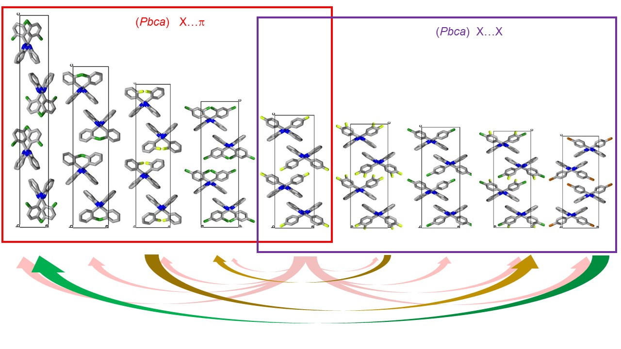

###### **Figure 1**. Unit cells of nine members of the exemplary isostructural series of halogen-substituted 2-phenylbenzimidazole derivatives showing gradual alteration. How far can we say that two selected structures of the series are isostructural? The determining intermolecular interactions switches in the middle of the molecular sequence.

#### [1] Bombicz, P., May, N. V., Fegyverneki, D., Saranchimeg, A. & Bereczki, L. (2020). *CrystEngComm*, **22**, 7193.

[2] Kálmán, A., Párkányi, L. & Argay, G. (1993). *Acta Cryst*. **B49**, 1039.

[3] Kálmán, A. (1996). Fundamental Principles of Molecular Modelling. New York: Plenum Press.

[4] Kálmán, A. & Párkányi, L. (1997). Isostructurality of Organic Crystals. In Advances in Molecular Structure Research, Vol. 3, edited by M. Hargittai & I. Hargittai, pp. 189–226. Greenwich: JAI Press.

[5] Macrae, C. F., Bruno, I. J., Chisholm, J. A., Edgington, P. R., McCabe, P., Pidcock, E., Rodriguez-Monge, L., Taylor, R., van de Streek, J. & Wood, P. A. (2008). *J. Appl. Cryst*. **41**, 466–470.

[6] Bombicz, P. (2024). *IUCrJ.*, **11**, 3.