# Bacterial toxin interaction with human glycolipid: Structure of *Pseudomonas aeruginosa* lectin LecA/galactose complex using neutron macromolecular crystallography

## T. Arnaud1,2, J. Devos1, L. Gajdos1, E. Richard2, A. Varrot2, M. Blakeley1, A. Imberty2

### 1Institut Laue-Langevin, 71 Avenue des Martyrs, 38000 Grenoble, France. 2Université Grenoble-Alpes, CNRS, CERMAV, 38400 Saint-Martin-d’Heres, France

### arnaudt@ill.fr

The investigation of the interactions between pathogens and humans represents a crucial area of scientific research. Elucidating the mechanisms underlying infection processes can lead to the discovery of new treatments for pathogen-associated diseases. A key aspect of these interactions involves the recognition of carbohydrates, which occurs at various stages of infection. This recognition process encompasses the interactions between pathogens and their targets, as well as the immune response against the pathogens.

In our research project, we seek to examine the three-dimensional (3D) structure of bacterial toxins and virulence factors in complex with oligosaccharides present on the surface of human cells. Lectins are proteins or protein domains that bind to carbohydrates and play a crucial role in recognition processes [1]. To investigate these interactions, we will use neutron macromolecular crystallography (NMX) to determine the position of hydrogen atoms in 3D structures of lectin/carbohydrate complexes, aiming to elucidate the hydrogen-bonding involved in these interactions [2], [3].

This work focuses on a specific lectin: LecA from *Pseudomonas aeruginosa*. This protein targets a glycolipid, globotriaosylceramide (Gb3) consisting of a ceramide and a trisaccharide Galα1-4Galbβ1-4Glc, [4].

Perdeuterated LecA has been produced at ILL. Partially deuterated galactose (Gald10) has been obtained by chemical deuteration from collaborators (S. Vidal & S. Feuillastre, ICSN/CEA Paris-Saclay, Gif-sur-Yvette, France). In addition, we performed *E.coli* metabolism engineering to produce perdeuterated Gb3.

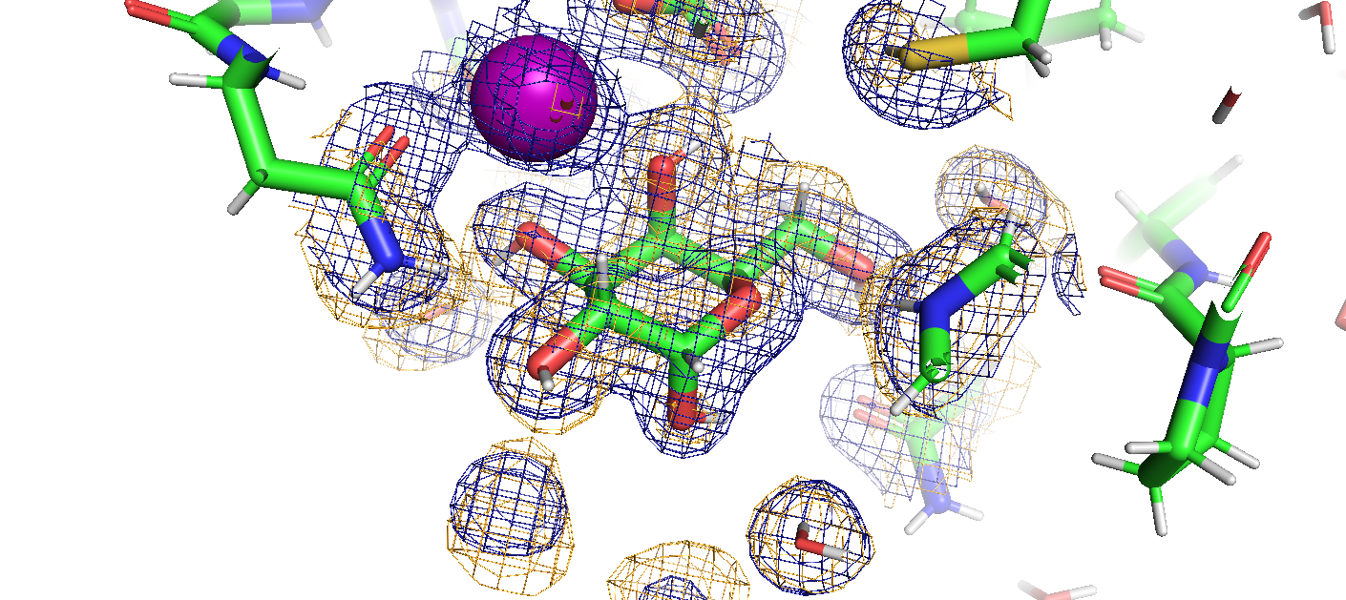The structure of perdeuterated LecA in complex with a partially deuterated galactose (Gald10) has been solved at 1.9Å resolution (Fig 1). Data collection has been performed at room temperature on LADI at ILL for neutron diffraction and BM07 at ESRF for X-ray diffraction. Neutron and X-ray co-refinement resulted in clear density maps for all deuterium atoms, revealing the protonation states of amino acids, the hydrogen bonds in the binding site, and the role of water molecules in the environment of the glycan.

###### **Figure 1**. Three-dimensional structure of LecA from *Pseudomonas aeruginosa* resolved using neutron macromolecular crystallography (NMX). The figure presents a close-up view of the ligand-binding site, displaying only the α-isomer of galactose. The 2FoFc electron density map is depicted in blue, while the 2FoFc neutron density map is shown in yellow, both contoured at 1σ.

|  |  |
| --- | --- |
|  |  |

[1] H. Lis and N. Sharon, “Lectins: Carbohydrate-Specific Proteins That Mediate Cellular Recognition,” *Chem. Rev.*, vol. 98, no. 2, pp. 637–674, Apr. 1998, doi: 10.1021/cr940413g.

[2] M. P. Blakeley, P. Langan, N. Niimura, and A. Podjarny, “Neutron crystallography: opportunities, challenges, and limitations,” *Current Opinion in Structural Biology*, vol. 18, no. 5, pp. 593–600, Oct. 2008, doi: 10.1016/j.sbi.2008.06.009.

[3] L. Gajdos, M. P. Blakeley, M. Haertlein, V. T. Forsyth, J. M. Devos, and A. Imberty, “Neutron crystallography reveals mechanisms used by Pseudomonas aeruginosa for host-cell binding,” *Nat Commun*, vol. 13, no. 1, p. 194, Jan. 2022, doi: 10.1038/s41467-021-27871-8.

[4] B. Blanchard *et al.*, “Structural Basis of the Preferential Binding for Globo-Series Glycosphingolipids Displayed by Pseudomonas aeruginosa Lectin I,” *Journal of Molecular Biology*, vol. 383, no. 4, pp. 837–853, Nov. 2008, doi: 10.1016/j.jmb.2008.08.028.