# Structural characterization and colour of CaMg0.5CoxNi0.5-xP2O7 (0.0 ≤ x ≤ 0.5) compositions

## M. A. Tena1, Mohammed S. M. Abdelbaky2,3, Camino Trobajo3, Santiago Garcia-Granda3,*

### 1 University of Jaume I - Castellon de la Plana (Spain), 2 University of Salamanca - Salamanca (Spain), 3 University of Oviedo – CINN(CSIC), Oviedo (Spain).

*\*s.garciagranda@cinn.es*

In our pursuit of developing more sustainable and environmentally friendly materials, we have created new color palettes through solid solutions. This study focuses on the structural characterization of CaMg₀.₅CoxNi₀.₅₋ₓP₂O₇ (where 0.0 ≤ x ≤ 0.5) compositions, prepared using the chemical co-precipitation method. To reduce the toxic and costly amounts of cobalt and nickel, we substituted half of the Ni(II) and/or Co(II) ions in CaMP₂O₇ (M = Ni, Co) with Mg(II) ions. We observed the formation of the CaNi₃(P₂O₇)₂ compound when 0.0 ≤ x ≤ 0.1; however, this structure was not present for x > 0.1, despite the existence of CaCo₃(P₂O₇)₂ reported in the literature [2]. In these structures, Co(II) and Ni(II) ions occupy octahedral sites. The presence of CaNi₃(P₂O₇)₂ was also confirmed during the crystallization of CaNiP₂O₄ from a melt of Ca₂P₂O₄ and Ni₂P₂O₄ in a 1:1 molar ratio [1]. The coloration in these compositions primarily arises from the presence of Co(II) and/or Ni(II) ions within the CaMP₂O₇ structure [1, 2]. Modified by the CaNi₃(P₂O₇)₂ when 0.0 ≤ x ≤ 0.1 and by the diphosphate phase, α-M2P2O7 (M = Mg, Ni, Co) present in all compositions in smaller amounts. The coordination numbers for M are 5 and 6 in this last structure.

The variation in unit cell parameters, as determined by diffraction profile refinement (Figure 1), indicates the formation of solid solutions with the triclinic structure of CaMP₂O₇ (M = Mg, Ni, Co) and with the monoclinic structure of M2P2O7 (M = Mg, Ni, Co).

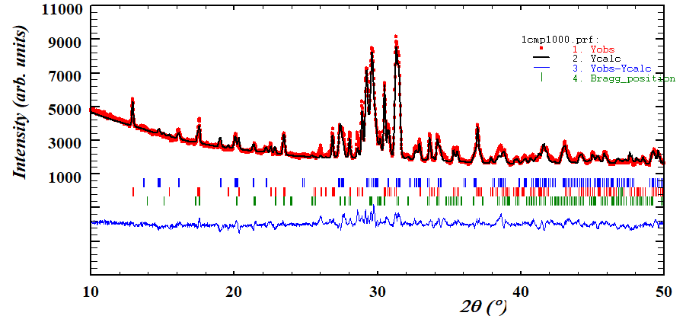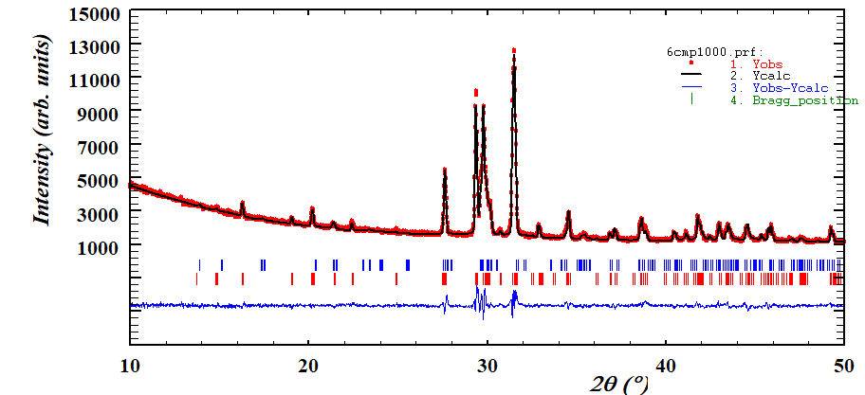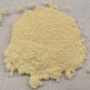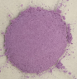

(a)

(b)

**Figure 1**. The diffraction profile refinement of CaMg0.5CoxNi0.5-xP2O7 (0.0 ≤ x ≤ 0.5) compositions with x = 0.0 (a) and x = 0.5 (b) fired at 1000 °C by Rietveld. The image of coloured material is shown in inset.

The Co–O bond distances in CaCoP₂O₇ range from 2.11 to 2.22 Å, while in CaCoSi₂O₇, they are between 1.83 and 1.87 Å. These variations influence the electronic transitions of octahedral Co(II) ions, leading to absorption bands at longer wavelengths (lower energies) in the UV-Vis spectra of CaCoP₂O₇, which corresponds to the violet color observed in the samples. In contrast, similar compositions in the diopside structure exhibit pink hues [4]. Transition bands of pentacoordinated Co(II) from diphosphate structure is also detected.

When incorporated into ceramic glazes, these compositions serve as ceramic dyes, with the resulting color in enamelled samples depending on the value of x. Intense green and blue colorations are achieved when these pigments are dissolved in commercial glazes, both in CaMg₀.₅CoxNi₀.₅₋ₓP₂O₇ (0.0 ≤ x ≤ 0.5) and CaMg₀.₅CoxNi₀.₅₋ₓSi₂O₆ (0.0 ≤ x ≤ 0.5) compositions.

#### [1] Funke, M., Blum, M., Glaum, R., ElBali, B. (2004). Z. Anorg. Allg. Chem., **630**, 1040-1047.

#### [2] Riou D., Labbe, P., Goreaud, M. (1988). C. R. Acad.Sci. Paris, **307**, 1751-1756.

#### [3] Kwang-Hwa Lii, Pei-Fen Shih and Teng-Ming Chen (1993). Inorg. Chem., **32**, 4373-4377.

[4] Tena, M. A., Abdelbaky, M. S. M., Trobajo, C., García, J. R., García-Granda, S., Ceramics International, **50** (2024) 20391-20401.

*We gratefully acknowledge the financial support provided by Spain´s Agencia Estatal de Investigación. Ministerio de Ciencia e Innovación, PID2020-113558RB-C41 and Principality of Asturias (IDE/2024/000742).*