# Nanocrystalline organic compounds: structure determination by a global fit to the pair-distribution function

## M.U. Schmidt1, R. Hühn1,2, J. Elsaß1

### 1Martin U. Schmidt, Robert Hühn and Jan Elsaß, Goethe-Universität, Institut für anorganische und analytische Chemie, Max-von-Laue-Str 7, 60438 Frankfurt am Main, Germany. 2Present address: **STOE & Cie GmbH,** Hilpertstr. 10, 64295 Darmstadt, Germany

### m.schmidt@chemie.uni-frankfurt.de

We develop a method for the determination of crystal structures of nanocrystalline organic compounds by a global fit to the pair-distribution function (Global-PDF-Fit). The method resembles the direct-space methods used to solve crystal structures from powder diffraction data, but (1) the fit is not performed to the powder pattern itself, but to the PDF, which is obtained from carefully measured powder data by Fourier transformation. (2) The method also works for unindexed powder data, i.e. if lattice parameters and space group are not previously known. The method is implemented in our program FIDEL [1]. The fits starts with a huge number (about 100 million) of random crystal structures in different space groups with random values for lattice parameters, molecular position and orientation. At first, structures with overlapping molecules are sorted out. Next, the PDFs of all structures are calculated and compared to the experimental PDF using a newly developed method based on cross-correlation functions [2,3]. The most promising structures are subjected to an automated fit to the PDF using a combination of FIDEL and TOPAS. Finally, the structures are refined by a user-controlled fit to the PDF. Hitherto, the method works for crystalline compounds [4]. Now we are developing it for nanocrystalline compounds. An example is Pigment Yellow 83, C36H32Cl4N6O8 (Fig. 1a). Using a powder with a domain size of only 10 nm (Fig. 1b), the crystal structure is reproduced with high accuracy (Fig. 1c). For a 10-nm domain size sample of Pigment Yellow 14 (C34H30Cl2N6O4), a similarly good result was obtained.

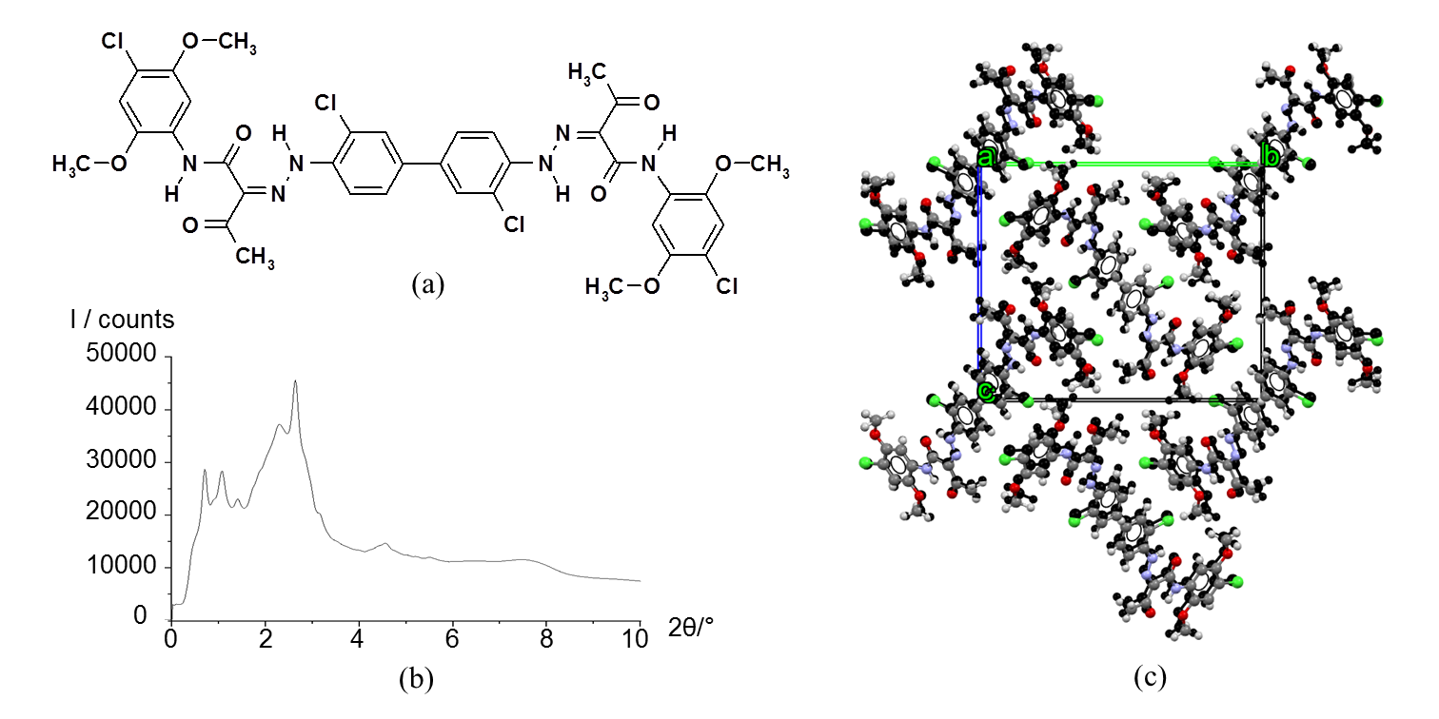

###### **Figure 1**. Pigment Yellow 83, sample with a domain size of 10 nm: (a) molecular formula, (b) low-angle part of the synchrotron X-ray powder pattern (wavelength 0.1614 Å, measured up to 60°, no further peaks). (c) Resulting crystal structure from global PDF fit (coloured) and from single-crystal data [5] (black).

#### [1] Habermehl, S., Mörschel, P., Eisenbrandt, P., Hammer, S. & Schmidt, M. (2014). Structure determination from powder data without prior indexing, using a similarity measure based on cross-correlation functions. *Acta Cryst.* B**70**, 347–359.

#### [2] Habermehl, S., Schlesinger, C. & Prill, D (2021). Comparison and evaluation of pair distribution functions, using a similarity measure based on cross-correlation functions. *J. Appl. Cryst.* **54**, 612–623.

#### [3] Habermehl, S., Schlesinger, C., Schmidt, M. U. & Prill. D. (2020). Vergleich von Atompaar-Verteilungsfunktionen mittels Kreuzkorrelations­funk­tionen (Comparison of atomic pair distribution functions using cross-correlation functions). German Patent Application 10 2020 004 292.9.

#### [4] Schlesinger, C., Habermehl, S. & Prill, D. (2021). Structure determination of organic compounds by a fit to the pair distribution function from scratch without prior indexing. *J. Appl. Cryst.* **54**, 776–786.

#### [5] Barrow, M. J.; Christie, R. M.; Badcock, T. D. (2003). The crystal and molecular structure of C.I. Pigment Yellow 83, a superior performance diarylide yellow pigment, *Dyes and Pigments*, **57**, 99–106.