# Lack of long-range order in ‘relaxor’ ferroelectric NH4Zn(HCOO)3 : diffuse and inelastic scattering study

## J. M. Bulled1*, A. Minelli2, A. Korshunov1, A. Bosak1

### 1ESRF, 71 Av. des Martyrs, 38000 Grenoble, France 2Oak Ridge National Laboratory, 1 Bethel Valley Rd, Oak Ridge, TN, USA

### *johnathan.bulled@esrf.fr

The proper description of order and disorder is of crucial important to the crystallography of ferroelectric materials (e.g. relaxors like PMN and mutiferroics), which are in turn highly important to modern and emerging devices [1,2]. Hybrid organic/inorganic materials offer novel routes to ferroelectricity and multiferroicity [3]. One such material, the hexagonal perovskite NH4Zn(HCOO)3 has recently been demonstrated – using quasi-elastic neutron scattering, NMR and neutron crystallography to display a complex disordered ground state and dynamics [4], leading authors to categorise it as a ‘relaxor’ ferroelectric. This study aims to understand the correlated disorder present in the material over a range of temperatures using several crystallographic and spectroscopic approaches.

Diffuse scattering (DS) measurements, understood via the 3D-DPDF method, can be separated into contributions from ZnO6 octahedra, and collective reorientations of the ammonium molecule which drive ferroelectricity [**Fig. 1A**]. Inelastic X-ray scattering (IXS) shows that the ZnO6 motion is dynamic (w ~ 4 meV) while the motion of ammonium is slower than the timescale probed [**Fig.  1B**]. We demonstrate that NH4 disorder is present in the form of planar DS down to the lowest experimental temperatures. Most interestingly, the ordering “Bragg”-like peaks show algebraically decaying tails at the lowest measured temperature (130 K), consistent with the theory for a frustrated nearest-neighbour Ising antiferroelectric [**Fig. 1C**] [5]. We argue that instead of being conventionally ordered, the ground state of the material hosts “quasi-long-range” order: the correlation functions still decay to zero (algebraically, rather than exponentially) at large distances. While studied in the context of magnetism such a state is without an analogue in ferroelectric materials [6].

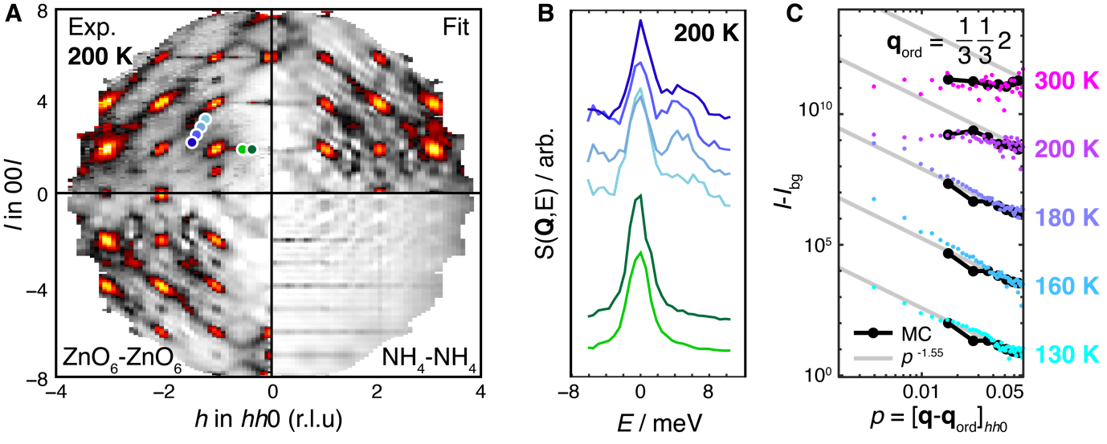

###### **Figure 1** **A.** DS measurement and *preliminary* fit, to the 3D-DPDF method, which can be separated into different contributions from displacive self-correlations of ZnO6 and N. **B.** IXS measured at points in reciprocal space shown in the previous sub-figure, showing that the planes of diffuse scattering are “static” with a frequency <<3meV, while the broad features are dynamic in nature **C.** Log-log plot showing the falloff of intensity around superstructure peaks follows a power law close to *I*-*I*bg ~ p-1.55 (gray) as predicted by MC simulation (black) and theory [5] for *T* < *T*C = 190K. Data for successive temperatures is offset in *y* for clarity.

#### [1] Hill, N. A. (2000). *J. Phys. Chem. B* **104**, 6694–6709.

[2] Liu, H., Shi, X., Yao, Y. *et al.* (2023). *Nat Commun.* **14**, 1007.

[3] Boström, H.L.B., Senn, M.S. & Goodwin, A.L. (2018). *Nat Commun.* **9**, 2380.

[4] Hitchings, T.J., Wickins, *et. al.* (2025). *Chin. J. Chem,* **43**, 1190-1198.

[5] Stevenson, J. (1970). *J. Math. Phys.* **11**, 413.

[6] Harcombe D. R., Welch P. G., Manuel P., Saines P. J., Goodwin A. L. (2016). *Phys. Rev. B* **94**, 174429.