Effect of phosphoryl group on a molecular structure:
Rethinking resonance-assisted hydrogen bonds in P-containing systems

A.Pietrzak¹, W. M. Wolf¹

¹Institute of General and Ecological Chemistry, Faculty of Chemistry, Lodz University of Technology

anna.pietrzak.1@p.lodz.pl
The impact of π-electron delocalization on intramolecular hydrogen bonds (intraHBs) seems well-known and extensively elaborated. However, since 1989, when Gilli et al. proposed a resonance-assisted hydrogen bonding (RAHB) model, suggesting a synergistic reinforcement between π-resonance and intraHB, many contradictive sounds of both criticism and confirmation appeared. According
to Gilli's concept of RAHB, its formation causes an apparent affinity for bond equalization in the resulting quasi-aromatic ring.[1]
The first trace of criticism of Gilli's concept appeared when Ramos et al.[2] explained the HB by the Mills-Nixon effect. Since then, many studies have commented on the impact of delocalization, resonance, and aromaticity on intraHBs.[3,4] Currently, alongside works undermining the RAHB concept, results confirming Gilli's RAHB idea also appear. Multiple concepts on the influence of resonance
on intraHB (Scheme 1) revealed that the impact of π-electron delocalization is more complex than postulated by Gilli et al. Interestingly, most studies on intraHBs affected by electron delocalization refer to systems where donor and acceptor atoms are linked through
the homonuclear conjugated system of CC bonds. On the other hand, reports on intraHB engaging π-electrons of heteronuclear conjugated systems are very scarce. The Cambridge Structural Database (CSD) survey exposed the disproportion in deposited structures containing particular intraHB systems (only 13 structures containing O-H…O=P synthon).
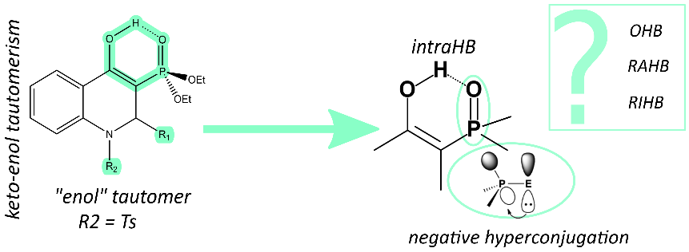

Figure 1. Phosphorylated hydroquinolinoles as a model series for characterization of intraHB defined by O-H…O=P synthon.
Herein, we present intraHB defined by O-H…O=P synthon (Figure 1). To our knowledge, there is no report on such intraHB except
for a few publications [5] that note the existence of RAHB. However, the actual nature of the interaction has not been investigated
so far.The formation of a planar quasi-ring by the hydrogen bond suggests a resonance-assisted hydrogen bond (RAHB). However, the geometrical parameters of the HB shed new light on the nature of the observed interaction and suggest that negative hyperconjugation describing the stereoelectronic structure of the phosphoryl group may provide a significant influence on the intraHB. The structures were characterized using a single-crystal X-ray experiment augmented by neutron diffraction results. The analysis is supported
by spectroscopic characterization of studied compounds and quantum-chemical calculations (QTAIM, NBO).

[1] G. Gilli, F. Bellucci, V. Ferretti, V. Bertolasi, J. Am. Chem. Soc 1989, 111, 1023.

[2] M. Ramos, I. Alkorta, J. Eiguero, Tetrahedron, 1997,53, 1403.
[3] J. M. Guevara-Vela, E. Romero-Montalvo, A. Costales, Á. M. Pendás, T. Rocha-Rinza, Phys.Chem.Chem.Phys. 2016, 18, 26383.
[4] R. W. Góra, M. Maj, S. J. Grabowski, Physical Chemistry Chemical Physics 2013, 15, 2514.
[5] J. Koszuk, T. Bartosik, J. Wojciechowski, W. M. Wolf, A. Janecka, J. Drogosz, A. Długosz, U. Krajewska, M. Mirowski, T. Janecki, Chem. Biodivers. 2018, 15, e1800242.
The work has been supported by National Science Centre, Poland (NCN) and 2019/03/X/ST4/01389 within the programme „FU2 N – Fundusz Udoskonalania Umiejętności Młodych Naukowców” supporting scientific excellence of Lodz University of Technology, under the contract No W-3D/FU2N/8/2024
We gratefully acknowledge the Science and Technology Facilities Council (STFC) for access to neutron beamtime at ISIS (SXD facility).

