Quantum crystallographic refinements from Machine Learning – Performance and speed benchmarks

F. Kleemiss¹, L. M. Seifert¹, D. Bruex¹

¹RWTH Aachen University, Insittute of Inorganic Chemistry, Landoltweg 1a, 52074 Aachen, Germany

florian.kleemiss@ac.rwth-aachen.de
The refinement of X-ray and electron diffraction data benefits greatly from implementing a tailor-made model of the non-spherical atomic electron density, as shown in many previous works.[1–3] The major drawback of these methods is the significantly increased computational effort required, as is the case for Hirshfeld Atom Refinement (HAR), or the limitation of applicability in case of transferable aspherical atom models (TAAM).[4]
To overcome this limitation, we incorporate two new possibilities in the framework of NoSpherA2, the interface to non-spherical atoms in Olex2:[2] the interface to the PTB program[5] package for semi-empirical QM calculations, as well as a newly developed workflow incorporating the Symmetry-adapted learning of three-dimensional electron densities (SALTED),[6,7] trained on large sets of molecular geometries obtained by meta-dynamics simulations. One of the biggest advantages of the chosen implementation – Gaussian Process Regression - is the possibility to give uncertainty measures of predicted values, allowing in operando judgment of the prediction results.
We will compare refinement results obtained from the established models, including classical HAR on different levels of theory, alongside results from the new implementations, and highlight performance and weaknesses of each approach on a large set of benchmark diffraction data.
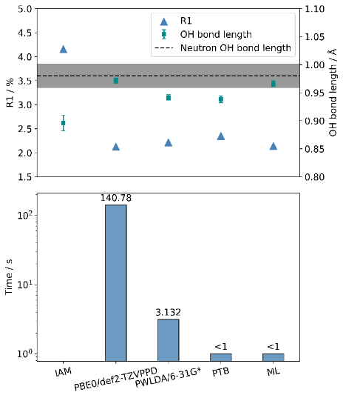

Figure 1. Comparison of R-value(top, triangle), performance against neutron diffraction data(top, square), and timing on a logarithmic scale (bottom) of IAM, high-level HAR, low-level HAR, semi-empirical method (PTB), and the Machine Learning Model (ML) performed on a desktop computer.

[1] M. Woińska et al., Sci. Adv., 2 (2016), e1600192.

[2] F. Kleemiss, et al., Chem. Sci. 12 (2021), 1675–1692.

[3] B. Gruza, et al., Acta Cryst. A76 (2020), 92–109.

[4] K. K. Jha, et al., J. Appl. Cryst. 56 (2023), 116–127.
[5] S. Grimme, et al., J. Chem. Phys. 158 (2023), 158, 124111.
[6] A. Grisafi, et al., J. Chem. Theory Comput. 19 (2023), 4451–4460.
[7] A. M. Lewis, et al., J. Chem. Theory Comput. 17 (2021), 7203–7214.

We greatly acknowledge the discussion and help from Marianna Rossi and her group from the Max Planck Institute for the Structure and Dynamics of Matter.

