# Program for automatic checking of crystal structure solution results based on comparison with DFT calculation results

## F. Fňukal

### University of Chemistry and Technology, Prague, Technická 5, 166 28 Praha 6 – Dejvice

### fnukalf@vscht.cz

Crystal structure validation based on comparison with DFT calculation results was already introduced circa 20 years ago [1, 2]. However, only the advancement in computing technology as well as the development in DFT functionals made it possible to perform such calculations on complex crystal structures.

To facilitate performing DFT calculations on crystal structures we developed the program checkCIF-DFT. An inspiration to us was the validation system checkCIF/PLATON [3], which offers consistency and validity checking for experimental crystal structures based on crystallographic diffraction criteria. There already exists commercial software offering the possibility of performing DFT calculations on crystal structures, however, it is typically fairly expensive. Our aim is therefore to present a freely available variant of such software. Our program internally utilizes the DFT programs Quantum ESPRESSO [4] and CASTEP [5]. Our program provides a graphical interface and serves as a mediator between the user and computational programs. Our program can read and visualize data from CIF files, prepare input files for computational programs, monitor the progress of calculations and finally, after a calculation has finished, it can analyse the calculation results and point out serious issues.

In our initial testing, we chose a set of proven fraudulent structures [6] to see if the DFT method would be able to detect serious issues and a set of neutron diffraction structures, which we deemed to be the most reliable. We also conducted a test for a set of randomly selected CSD structures. To analyse the results, we developed a system of comparison descriptors by extending upon previous work of other authors [1, 2]. When analysing the results, we concluded that the DFT method together with our improved descriptor system was able to detect that the fraudulent structures were erroneous (Fig. 1). It also brought into question the reliability of some of the CSD contents.

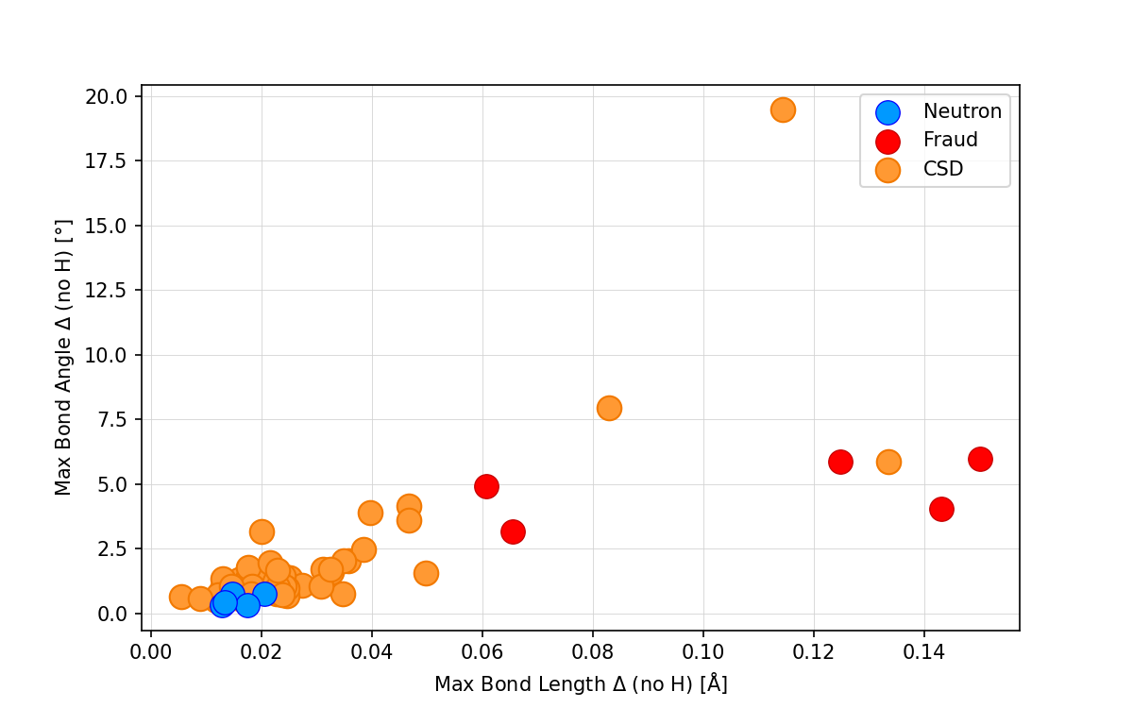

###### **Figure 1**. Maximal bond length difference against maximal bond angle difference (excluding hydrogen atoms) for a group of structures solved by neutron diffraction, group of proven fraudulent structures and a group of randomly selected CSD structures.

#### [1] van de Streek, J., Neumann, M. A. (2010). *Acta Crystallogr., Sect. B: Struct. Sci.* **66**, 544.

#### [2] van de Streek, J., Neumann, M. A. (2014). *Acta Crystallogr., Sect. B: Struct. Sci.* **70**, 1020.

#### [3] Spek, A. L. (2003). *J. Appl. Crystallogr.* **36**, 7.

[4] Giannozzi, P., et al (2009) *J. Phys.: Condens. Matter* **21**, 395502

[5] Clark, S. J., Segall, M. D., Pickard, C. J., Hasnip, P. J., Probert, M. I. J., Refson, K., Payne, M. C. (2005) *Z. Kristallogr.* **220**, 567.

[6] Harrison, W. T. A., Simpson, J., Weil, M. (2010) *Acta Crystallogr. Sect. E: Struct. Rep. Online* **66**, e1.

This work was supported by the Ministry of Education, Youth and Sports of the Czech Republic through the e-INFRA CZ (ID:90254). The authors gratefully acknowledge the Czech Science Foundation for financial support of the project no. 21-05926X.