# Betatron Radiation Compact Sources: Tapping Opportunities in Cultural Heritage and Life Sciences

## M. Gaboardi1,2*, M. Anania3, A. Biagioni, G. Costa3, L. Crincoli3,4, M. Del Giorno3, M. Ferrario3, F. Galdenzi1,2, M. Galletti1,2, S. Lauciani3, A. Liedl3, V. Lollo3, F. Villa3, A. Cianchi1,2, F. Stellato1,2.

### 1Department of Physics, University of Rome Tor Vergata, Via Della Ricerca Scientifica 1, 00133, Rome, Italy. 2INFN Tor Vergata, Via Della Ricerca Scientifica 1, 00133, Rome, Italy. 3INFN-LNF, Via Enrico Fermi, 00044 Frascati, Italy. 41Department of Physics, University of Rome La Sapienza, Piazzale Aldo Moro 5, 00185 Rome, Italy.

### *mattia.gaboardi@uniroma2.it

When an intense laser (driver) pulse is focused into a plasma, it can accelerate electrons to GeV-scale energies over short distances, causing them to wiggle at relativistic speed emitting an intense, focused radiation. This phenomenon, known as Laser Wake-Field Acceleration (LWFA) [1], provides a compact and cost-effective avenue to produce a relatively coherent X-ray source with the brightness and spectral characteristics of synchrotron light, combined with a pulsed temporal structure, typical of Free-Electron Lasers (FELs).

The EUPRAXIA Advanced Photon Source (EuAPS), currently under development at the Frascati National Laboratory (LNF, Italy), aims to establish experimental capabilities by the end of 2025 (see Fig. 1*a*). The driver pulse is generated by the Frascati Laser for Acceleration and Multidisciplinary Experiments (FLAME) system, delivering 25 fs width pulses at 200 TW peak power with a 1-5 Hz repetition rate. This configuration is designed to deliver X-ray pulses with ~109 photons per pulse, a brightness of ~1021 photons/s/mrad2/mm2/0.1%BW, a beam size of a few µm, and photon energies spanning 1-10 keV (see Fig. 1*b*) [2].

Commissioning of a preliminary experimental beamline is underway, featuring a 3-meter-long experimental chamber equipped with motorized slits and interchangeable filters, a XYZ-ω sample stage, a movable 2048×2048 pixels CCD X-ray detector, and various sample environment [3]. The chamber is modular in design, permitting additional integration of optical components and detectors for forthcoming applications.

Limited to structural sciences, such source shows promise for crystallographic studies of organic and biological structures, benefiting from the 1–10 keV photon range, as well as in phase contrast imaging and X-ray absorption spectroscopy. Additionally, the micron-sized beam is ideal for spatially resolved investigations of heterogeneous specimens, with potential applications in cultural heritage science where non-destructive analysis of small features is often required.

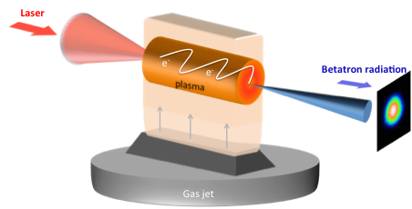(*a*) 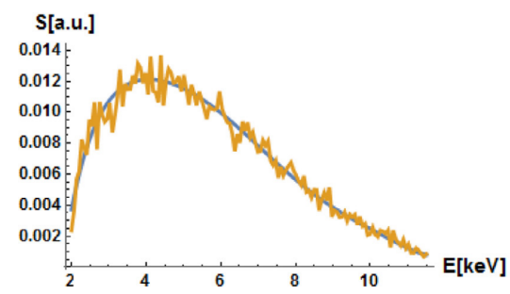 (*b*)

###### **Figure 1**. (*a*) Scheme behind betatron radiation production at FLAME laser facility. (b) Energy profile of EuAPS betatron source.

###### 

[1] W. Lu, M. Tzoufras, C. Joshi, F.S. Tsung, W.B. Mori, J. Vieira, R.A. Fonseca, L.O. Silva, Generating multi-GeV electron bunches using single stage laser wakefield acceleration in a 3D nonlinear regime, Phys. Rev. Spec. Top. - Accel. Beams 10 (2007) 061301.

[2] A. Curcio, M. Anania, F. Bisesto, E. Chiadroni, A. Cianchi, M. Ferrario, F. Filippi, D. Giulietti, A. Marocchino, F. Mira, M. Petrarca, V. Shpakov, A. Zigler, First measurements of betatron radiation at FLAME laser facility, Nucl. Instruments Methods Phys. Res. Sect. B Beam Interact. with Mater. Atoms 402 (2017) 388–392.

[3] F. Galdenzi, M.P. Anania, A. Balerna, R.J. Bean, A. Biagioni, C. Bortolin, L. Brombal, F. Brun, M. Coreno, G. Costa, L. Crincoli, A. Curcio, M. Del Giorno, E. Di Pasquale, G. di Raddo, V. Dompè, S. Donato, Z. Ebrahimpour, A. Falone, A. Frazzitta, M. Galletti, A. Ghigo, S. Lauciani, A. Liedl, V. Lollo, A. Marcelli, E. Principi, A.R. Rossi, F. Stocchi, F. Villa, M. Zottola, A. Cianchi, F. Stellato, M. Ferrario, The EuAPS Betatron Radiation Source: Status Update and Photon Science Perspectives, Condens. Matter 9 (2024) 30.