# Local structure and dynamics in MPt(CN)6 Prussian blue analogues

## E. A. Harbourne1, H. Barker1, Q. Guéroult1, J. Cattermull1, L. A. V. Nagle-Cocco2, N. Roth1, J. S. O. Evans3, D. A. Keen4, A. L. Goodwin1

### 1Department of Chemistry, University of Oxford, Oxford OX1 3QR, U.K., 2Cavendish Laboratory, University of Cambridge, Cambridge CB3 0HE, U.K., 3Department of Chemistry, Durham University, Durham DH1 3LE, U.K., 4ISIS Facility, Rutherford Appleton Laboratory, Didcot OX11 0QX, U.K.

### elodie.harbourne@chem.ox.ac.uk

Negative thermal expansion (NTE)—the phenomenon of contraction on heating—has been identified in several cyanide-based molecular framework materials, including in the Prussian blue analogues (PBAs) [1-4]. The parent structure of PBAs is a cubic net assembled from transition-metal ions at the octahedral nodes, connected by linear M–CN–M linkages. The NTE mechanism in PBAs is usually described in terms of the thermal population of transverse vibrations of M–CN–M linkers coupled to rotations of the transition-metal coordination octahedra [1-3]. While many PBAs can contain a variety of different distortions and defect structures [5], the transition-metal hexacyanoplatinates, MIIPtIV(CN)6, are effectively defect-free [3]. Consequently, their local structures can be characterised by thermal (phonon-driven) displacements away from their average structure. Hence, in the hexacyanoplatinates, a direct relationship between local structure and dynamics can be expected.

We use a combination of X-ray pair distribution function (PDF) measurements, lattice dynamical calculations, and ab initio density functional theory (DFT) calculations to study the local structure and dynamics in various MPt(CN)6 Prussian blue analogues [6]. In order to link directly the local distortions captured by the PDF with the lattice dynamics of this family, we develop and apply a new Monte Carlo-driven, ‘interaction-space’ PDF refinement approach based on the optimisation of harmonic force constants, from which the (experiment-derived) low-energy phonon dispersion relations can be approximated. Calculation of the corresponding Grüneisen parameters allows us to identify correlated tilts of coordination octahedra as the key modes responsible for NTE in these materials.

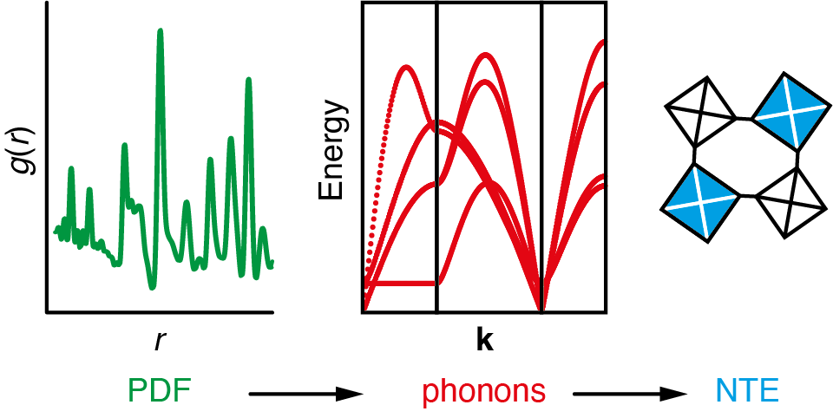

###### **Figure 1**. A new ‘interaction-space’ PDF refinement approach has been developed, which yields effective harmonic force constants from which the (experiment-derived) low-energy phonon dispersion relations can be approximated. Calculation of the corresponding Grüneisen parameters allows the identification of the key modes responsible for NTE (correlated octahedral tilts).

#### [1] Margadonna, S., Prassides, K. & Fitch, A. N. (2004). *J. Am. Chem. Soc.,* **126**, 15390.

#### [2] Goodwin, A. L., Chapman, K. W. & Kepert, C. J. (2005). *J. Am. Chem. Soc.*, **127**, 17980.

#### [3] Chapman, K. W., Chupas, P. J. & Kepert, C. J. (2006). *J. Am. Chem. Soc.*, **128**, 7009.

#### [4] Adak, S., Daemen, L. L., Hartl, M., Williams, D., Summerhill, J. & Nakotte, H. (2011). *J. Solid State Chem.*, **184**, 2854.

[5] Cattermull, J., Pasta, M. & Goodwin, A. L. (2021). *Mater. Horiz.*, **8**, 3178.

[6] Harbourne, E. A., Barker, H., Guéroult, Q., Cattermull, J., Nagle-Cocco, L. A. V., Roth, N., Evans, J. S. O., Keen, D. A. & Goodwin, A. L. (2024). *Chem. Mater.*, **36**, 5796.