# Exploring structural disorder in natural and synthetic pyrochlores through single crystal X-ray diffuse scattering

## G.O. Lepore1, M. Morana1, A. Taddei1, S. Margheri1, E. Schmidt2

### 1Department of Earth Sciences, University of Florence, Via G. La Pira 4, 50121, Firenze. Italy, 2Faculty of Geosciences, MARUM and MAPEX, University of Bremen, Klagenfurter Straße 2-4, 28359 Bremen, Germany

### giovanniorazio.lepore@unifi.it

Pyrochlore minerals and their synthetic analogues have been the focus of considerable research due to their complex crystal-chemical features and diverse applications across various scientific and technological fields. The general formula is A2–*m*B2X6–*w*Y1–*n* and the structure can be described as a framework of BX6 octahedra that form tunnels along [110], where the interstitial A and Y sites are hosted [*e.g.* 1]. Ion-exchange processes may easily take place at the A and Y sites, determining the ability of pyrochlores to incorporate large heavy metal cations from aqueous solutions which presents interesting environmental implications. Pyrochlores are, however, known for hosting extensive positional disorder, mainly related to the position of tunnel cations, making it quite challenging to understand the structural role of such cations and the framework response with respect to their distribution, size, and charge [*e.g.* 2].

In order to get information on the causes and nature of disorder in pyrochlores, we performed single-crystal X-ray diffuse scattering (DS) studies on a natural hydropyrochlore [2], ideally (H2O,◻)2Nb2(O,OH)6(H2O), and a synthetic elsmoreite, *i.e.* having the B site mainly occupied by W, with the Y site bearing Na+. We also carried out DS studies on a hydropyrochlore crystal where the A site is mainly occupied by Tl following ion-exchange experiments in a Tl-rich solution. The diffuse scattering was analysed using 3D-ΔPDF [3], which served as the basis for constructing a disordered model for quantitative evaluation.

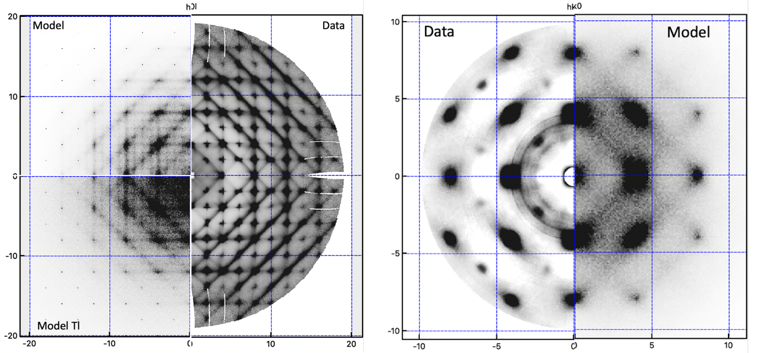

###### **Figure 1**. Symmetry-averaged diffuse scattering data for synthetic elsmoreite (left) and natural Tl-treated hydropyrochlore (right) together with the developed Monte Carlo model.

The synthetic Na-bearing elsmoreite displays intense diffuse streaks that seem to be primarily linked to the rotation of octahedra together with distortion of the channels (Fig. 1, left). On the other hand, while the untreated hydropyrochlore sample shows almost no DS signal, the sample treated with Tl+ displays broad diffuse features which can be interpreted as due to an interaction between the framework and the tunnel cations, with a displacement of Tl+ along [111].

#### [1] Subramanian, M. A., Aravamudan, G., & Rao, G. S. (1983) *Prog. Solid St. Chem.* **15**, 55.

#### [2] Taddei, A., Bindi, L., Lepore, G.O., Skogby, H. & Bonazzi, P. (2024) *Am. Min.* **109**, 1913.

[3] Weber, T. & Simonov, A. (2012). *Z. Kristallogr.* **227**, 238.