# Terpene based co-crystals for the protection from biodeteriogens in archives and libraries

## A. Ienco1, A. Guerriero1, E. Palagano2, C. Santini2, F. Ieri2, G. Cencetti2, D. Bonetti2, L. Della Maggiora2, A. Crisci3, F. Menicucci4, A. Sidoti5, P.P. Mazzeo6, A. Bacchi6

### 1Consiglio Nazionale delle Ricerche – Istituto di Chimica dei Composti OrganoMetallici, Via Madonna del Piano 10, Sesto Fiorentino, Italy, 2Consiglio Nazionale delle Ricerche – Istituto di Bioscienze e BioRisorse, Via Madonna del Piano 10, Sesto Fiorentino, Italy, 3Consiglio Nazionale delle Ricerche – Istituto di BioEconomia, Via Madonna del Piano 10, Sesto Fiorentino, Italy, 4Consiglio Nazionale delle Ricerche – Istituto per la Protezione Sostenibile delle Piante, Via Madonna del Piano 10, Sesto Fiorentino, Italy, 5National Central Library of Florence, Piazza dei Cavalleggeri 1, Firenze,, Italy, 6Department of Chemistry, Life Sciences and Environmental Sustainability, University of Parma, Parco Area delle Scienze 11/a, Parma, Italy

### andrea.ienco@cnr.it

Until recently, paper was one of the most used media for the conservation of written knowledge. Fungi, as biological agents, are the major paper biodeteriogens, and several strategies have been tested to reduce their action.[1] We have proposed and tested phenazine-based cocrystals of thymol, carvacrol and eugenol (terpenes that can be found in aromatic plants such as thyme, oregano and cloves) as a new tool for the control of paper-degrading agents by indirect contact . [2,3] In cocrystals, the release of the active molecules, being controlled by the intermolecular forces within the cocrystal, is moderate respect to the terpenes in their pure phases, allowing for a prolonged efficacy of the treatment. The phenazine:carvacrol cocrystal (Figure 1) with a molar ratio 2:1 was the most active when tested *in vitro* [3] and it was able to prevent fungi growth inside a book prototype made of Whatman and Kraft paper inoculated with a mix of fungal species. [4] The treatment with the cocrystal did not show any treatment-induced paper degradation. [4] The effectiveness of the treatment was also tested inside a compactus type shelving unit.

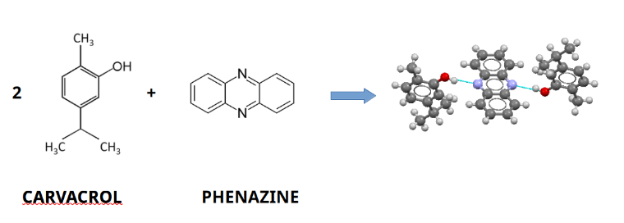

###### **Figure 1**. Schematic representations of the phenazine carvacrol cocrystal

#### [1] Sequeira, S., Cabrita, E.J., Macedo, M.F., (2012) *Int. Biodeterior. Biodegrad.* *74*, 67–86.

#### [2] Mazzeo, P. P., Carraro, C., Monica, A., Capucci, D., Pelagatti, P., Bianchi, F., Agazzi, S., Careri, M., Raio, A., Carta, M., Menicucci, F., Belli, M., Michelozzi, M., & Bacchi, A. (2019). ACS Sustainable Chemistry & Engineering, 7(21), 17929–17940.

#### [3] Menicucci, F., Palagano, E., Michelozzi, M., Cencetti, G., Raio, A., Bacchi, A., Mazzeo, P. P., Cuzman, O. A., Sidoti, A., Guarino, S., Basile, S., Riccobono, O., Peri, E., Vizza, F., & Ienco, A. (2022). *Int. Biodeterior. Biodegrad.*, *174*, 105469.

#### [4] Menicucci, F., Pizzo, B., Salvadori, B., Chelazzi, L., Ienco, A., & Palagano, E. (2024). *Int. Biodeterior. Biodegrad.* *195*, 105894.

Regione Toscana and Giovanisì (www.giovanisi.it), the project of the Tuscany Region for the autonomy of young people, are acknowledged for funding SCRIBA (Sviluppo di CRIstalli contro i biodeteriogeni di Biblioteche ed Archivi, CUP B93C24000770005) with the resources of the PR Toscana FSE+ 2021-2027. Makros srl is acknowledged for the loan of a compactus prototype of the BlockFire® series.