Non-covalent interactions in silver(I) mixed-ligand complexes

Tristan K. Theunissen,¹ Vincenzo La Gorcé,¹ Catharine Esterhuysen,² and Susan A. Bourne¹

¹Centre for Supramolecular Chemistry Research, Department of Chemistry, University of Cape Town, Rondebosch 7701, South Africa

²Department of Chemistry & Polymer Science, University of Stellenbosch, Matieland 7602, South Africa

E-mail: susan.bourne@uct.ac.za

Non-covalent interactions (NCIs) between metal and halogen atoms influence molecular and material stability and reactivity, facilitating the creation of new materials with specific properties and enhancing our understanding of molecular recognition [1]. Interactions between metals and halogens form two types of polar NCIs:semi-coordination bonds (sXBs) or halogen bonds (XBs), depending on the electron-rich and electron-deficient regions involved, with distinct electrophilic or nucleophilic characteristics [2].
A series of mixed-ligand silver(I) compounds containing benzoate (OBn) and neutral pyridyl ligands offers insight into various metal-involved interactions [3, 4]. We assessed metal+···metal+, metal+···Caromatic and metal+··· X (where X=Br or I) interactions in crystal packing, using quantum theory of atoms in molecules (QTAIM) and natural bond orbital (NBO) analysis. The strength of these interactions followed the the order Ag+···I(C) > Ag+···Ag+ > Ag+···Br(C) > Ag+···(C)aromatic. Bromine and iodine substituents enhance stability via Ag+···X(C) sXBs.
Crystal packing analysis of compounds with and without halogen substituents will also be presented to highlight the differences in molecular conformations and geometries observed.

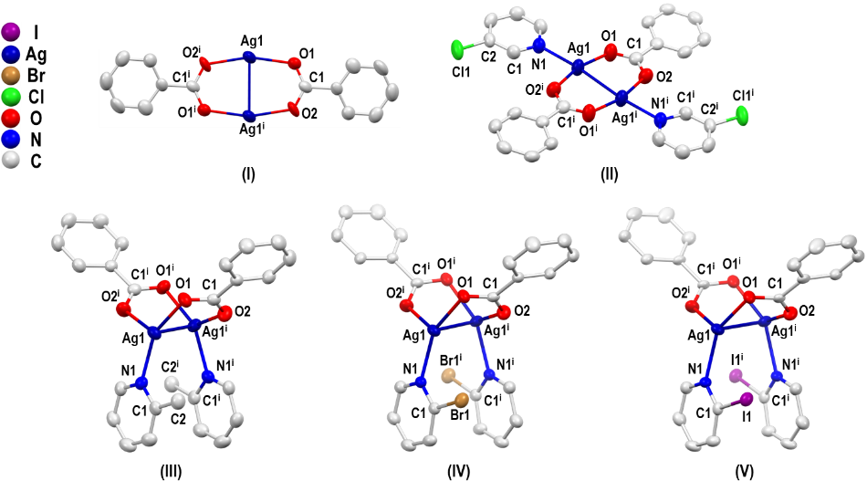

Figure 1. Crystal structures of compounds I-V with atom labels. Ellipsoids drawn at 50% probability level.

REFERENCES

[1] F. Zapata, L. González, A. Caballero, A. Bastida, D. Bautista, P. Molina, J. Am. Chem. Soc.,2018, 140, 2041-2045.

[2] Z.M. Bikbaeva, D.M. Ivanov, A.S. Novikov, I.V. Ananyev, N.A. Bokach, V.Y. Kukushkin,. Inorg. Chem. 2017, 56, 21, 13562–13578.

[3] T. K. Theunissen, C. Esterhuysen, S.A. Bourne, Cryst. Growth Des., 2024, 24, 9254-9265.

[4] V. la Gorcé ,T.K. Theunissen, S. A. Bourne, manuscript under review.

