# Ultrafast pair distribution function as a probe of hidden states in quantum materials

## Emil S. Bozin

### Center for Solid State Physics and New Materials, Institute of Physics Belgrade, University of Belgrade, Serbia

### bozin@ipb.ac.rs

Understanding how materials evolve under non-equilibrium conditions requires experimental tools capable of capturing both local structural changes and their ultrafast dynamics. Ultrafast X-ray pair distribution function (uf-PDF) analysis—based on total scattering measurements enabled by femtosecond X-ray free-electron lasers (XFELs)—now allows direct access to transient local structures beyond the constraints of crystallographic symmetry and long-range order, Fig. 1. Here, we will discuss how resolving hierarchical structural evolution on femtosecond to picosecond timescales provides critical insight into transient states and hidden orders that often govern the functional behavior of complex quantum materials [1].

Recent advances have demonstrated that high-quality total scattering data and corresponding PDFs can be obtained from a single ~30 fs XFEL pulse over an extended Q-range. This capability further enables detailed structural analysis of crystalline, nanocrystalline, amorphous, and liquid systems alike [2]. These developments open new frontiers for time-resolved investigations of lattice instabilities, correlated electron phenomena, and the competition between intertwined orders in quantum materials [3].

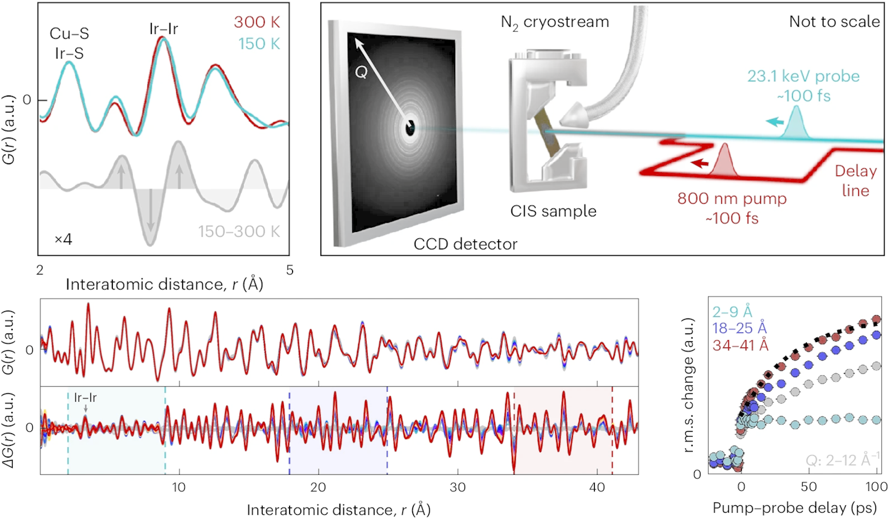

###### **Figure 1**. Resolving length-scale-dependent transient disorder through an ultrafast phase transition in CuIr2S4.

#### [1] Griffiths, J., Suzana, A. F., Wu, L., Marks, S.D., Esposito, V., Boutet, S., Evans, P. G., Mitchell, J. F., Dean, M. P. M., Keen, D. A., Robinson, I., Billinge, S. J. L., & Bozin, E. S. (2024). *Nature Materials*,**23***,* 1041.

#### [2] Sapnik, A. F., Chater, P. A., Keeble, D. S., *et al*. (2025). *arXiv:*2504.21462.

#### [3] Bozin, E. S., Abeykoon, M., Conradson, S., Baldinozzi, G., Sutar, P., & Mihailovic, D. (2023). *Nature Communications*, **14**, 7055.

Work at IPB and this presentation are supported by the European Union’s Horizon Europe research and innovation programme ERA Chair project HIP-2D-QM under the grant agreement No 101185375. Work at Brookhaven National Laboratory was supported by US DOE-BES under contract DE-SC0012704