# Local distortions and orbital disorder in Ce0.5Ba0.5MnO3 as seen by neutron PDF

## Elizabeth R. Arnold1,2, Mark Senn1, Nick Funnell2

### 1Department of Chemistry, University of Warwick, Gibbet Hill, Coventry, CV4 7AL, U.K. 2ISIS Neutron and Muon Source, Rutherford Appleton Laboratory, Harwell, Oxford, Didcot, OX11 0QX, U.K.

### Email of communicating elizabeth.arnold@warwick.ac.uk

Perovskites are among the most functionally diverse materials, being highly tuneable through careful selection of chemical composition and external conditions. Interchanging the cation on the A-site is an effective tool to tune the properties of the perovskite, causing charge doping and variation in the tolerance factor. Introducing chemical *disorder* on the A-site, via the variance effect [1], can also be a strong control factor.

Ce0.5Ba0.5MnO3 has, to our knowledge, the highest reported A-site variance of any synthesised perovskite material. A recent study in the group revealed the potential this material has for stabilising strong magnetoelectric coupling. In order to realise this coupling, cation layering, octahedral tilting and C-type orbital ordering are all required [2]. However, high-resolution X-ray powder diffraction and neutron powder diffraction data have revealed that Ce0.5Ba0.5MnO3 retains an average cubic Pm-3m structure down to 10K and 1.5 K respectively. This is incompatible with the desired coupling and reveals that the A-site must be highly disordered, inducing local Jahn-Teller distortions. This conflict between the average cubic structure and necessity for local disorder makes Ce0.5Ba0.5MnO3 an interesting system in which to study the interplay between chemical disorder and orbital disorder of the Jahn-Teller long axes. We look to probe this using neutron powder diffraction total scattering measurements and subsequent PDF analysis.

(b)

(a)

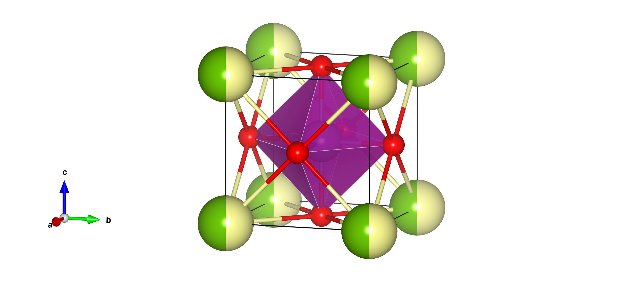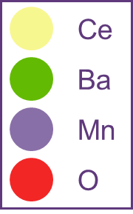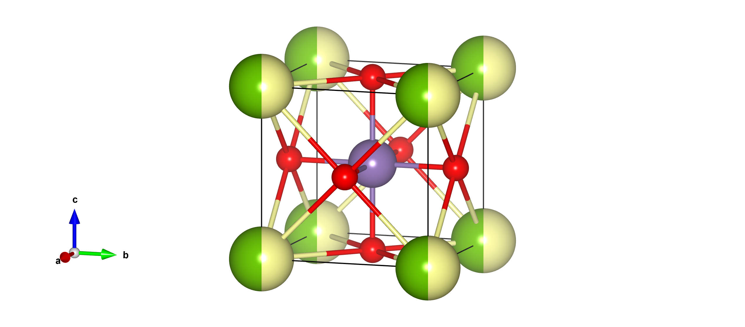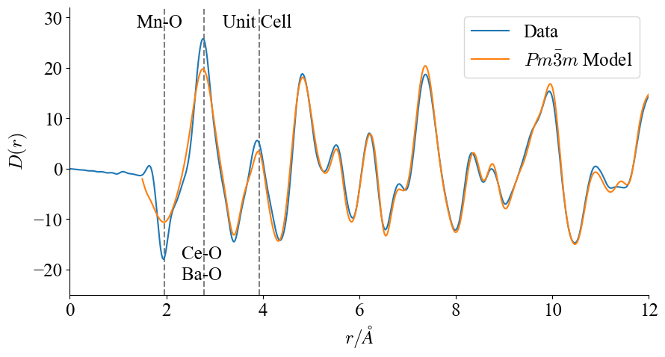

###### **Figure 1.** (a) Diagram of the Pm-3m unit cell of Ce0.5Ba0.5MnO3 with occupancies of 0.5 on both the Ce and Ba sites. (b) Plot of the generated PDF using total scattering diffraction data obtained at Polaris beamline (ISIS Neutron and Muon Source) [3] and the average cubic fit achieved using Topas Academic [4] small box modelling.

Figure 1(a) demonstrates the average cubic Pm-3m model with fractional occupancy on the A-site. Figure 1(b) demonstrates the cubic fit to the obtained PDF data. The large Qmax available at Polaris has allowed for generation of a PDF mostly free from truncation effects. The PDF has been modelled using the small box approach in Topas Academic. A reasonable fit is seen across the high-r range, with a Rwp of 15.0 achieved when fitting the region between 3.9A and 32A. However, extending this fit into the low-r (sub-unit cell) region yields a worsened Rwp of 18.0. The particularly poor fit around the Mn-O bond length at 1.96A combined with broad diffuse scattering visible in previous powder diffraction measurements taken at WISH (ISIS) suggests that local deviations from the average Pm-3m structure may be present.

I will present various models available to best describe this recently collected neutron powder diffraction data, evaluated using SAPA (Symmetry Adapted PDF Analysis [5]) a novel approach developed in the group. I will discuss to what extent short-range Jahn-Teller distortions are present in this new ultra-high A-site variance material and discuss the implications of its use as a multiferroic.

[1] Attfield, J. P. (1998). *Chem. Mater.* **10**, 3239-3248

[2] Simpson, S., Scott, C. A. M. (2024). *J. Mater. Chem. C.* **12**, 15058

[3] Smith, R. I., et al. (2019). *Rev. Sci. Instrum.* **90**(11), 115101

[4] Coelho, A. A. (2018). *J. Appl. Cryst.* ***51****, 210-218.*

[5] Bird, T. A., Herlihy, A., Senn., M. S. (2021). *J. Appl. Cryst.* **54**, 1514–1520.

The author would like to thank Struan Simpson for his guidance in this project. The author is also grateful to STFC for the provision of neutron beamtime at ISIS and to the instrument scientists Helen Playford and Gabriel Perez for their support.