# Calixarene-based multicomponent crystals: solvent selectivity, conformational dynamics, and supramolecular assembly

## M. Malinska1

### 1University of Warsaw, Faculty of Chemistry, Warsaw, Poland

### m.malinska@uw.edu.pl

Multicomponent crystal systems based on calixarenes offer a rich landscape for exploring molecular recognition, conformational adaptability, and supramolecular design. We present a systematic investigation of p-tert-butylcalix[6]arene (TBC6) and p-tert-butylcalix[8]arene (TBC8) crystallized from a wide range of solvents and guest molecules, yielding diverse stoichiometries, packing motifs, and host conformations. In the gas phase, the energy differences between TBC6 and TBC8 conformers can reach up to 100 kJ/mol, while the host–host interaction energies are often closely matched—making crystal formation a true playground of competing possibilities. TBC6 forms inclusion and exclusion complexes with stoichiometries ranging from 1:1 to 11:2 [1,2], governed by guest size, polarity, and apolar surface-to-volume ratios, with selective crystallization enabling separation of chlorobenzene [3]. Polymorphic and pseudopolymorphic transformations were observed, including solvent-driven kinetic trapping and thermodynamically guided reassembly. Building on this, we recently explored the crystal energy landscape of TBC6 using multicomponent solvent mixtures containing DMSO. Seven new solvates were obtained, including one bilayer structure with a winged-cone conformation and six isostructural forms with columnar packing of the macrocycle in a 1,2,3-alternate conformation (Fig. 1). These columns are stabilized by four strong TBC6–DMSO interactions—two hydrogen bonds and two C–H···π contacts. Host–host interactions dominate packing stabilization, with intracolumnar contributions twice as strong as intercolumnar ones, where additional solvent guests reside. DFT-calculated interaction energies and Hirshfeld surface analysis confirm tightly bound DMSO within the calixarene cavity and correlate with delayed release at elevated temperatures (~200 °C). TBC8 exhibits an even broader conformational space, adopting pleated-loop, chair, and a novel loop–chair conformation depending on the solvent (e.g., DMF, pyridine, DMSO), in agreement with DFT predictions [4]. Extending this understanding to biomolecular systems, sulfonato-calix[8]arene mediates protein assembly through persistent supramolecular synthons [5]. Altogether, these results show that multicomponent crystallization of calixarenes not only enables precise control over molecular and biomolecular architecture, but also exemplifies how crystal formation, though often unpredictable, can be systematically directed through thoughtful crystallization design.

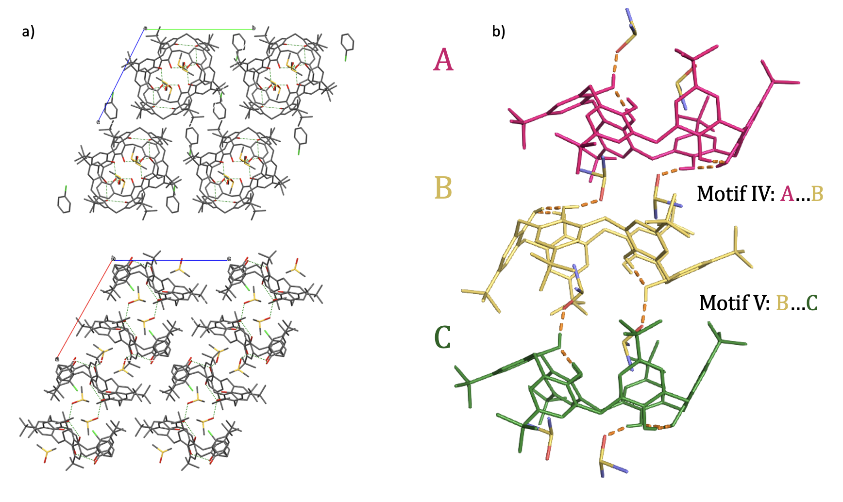

###### **Figure 1**. Crystal packing and host–host interactions in TBC6–DMSO solvates: a) Top and side views of columnar packing formed by TBC6 and DMSO; chlorobenzene molecules occupy the intercolumnar space. b) Motifs IV and V within a single column, highlighting host–host contacts.

#### [1] Malinska, M. *Cryst. Growth Des.* **2021**, *21* (2), 1103–1112.

#### [2] Malinska, M. *IUCrJ* **2022**, *9* (1), 55–64.

#### [3] Zaorska, E.; Stachowicz, M.; Malinska, M. *Cryst. Growth Des.* **2023**, 3455–3462.

#### [4] Kieliszek, A.; Malinska, M. *Cryst. Growth Des.* **2021**, *21* (12), 6862–6871.

#### [5] Flood, R. J.; Mockler, N. M.; Thureau, A.; Malinska, M.; Crowley, P. B. *Cryst. Growth Des.* **2024**, *24* (5), 2149–2156.

This work was financially supported by the Polish National Science Centre (NCN) under SONATA BIS 11 grant no. 2021/42/E/ST4/00229.