Chiral symmetry breaking in molecular crystals: emergence of isostructurality and tailored chirality

A. Andotra^{1,2}, C. Killalea¹, C. Zuffa³, F. Malagreca¹, P. Pandey³, L. Maini³, V. Lemaur⁴, M. Surin⁴, R. Resel², Y. Geerts¹

¹ ULB, Chimie des Polymères, Campus de la Plaine 1050 Brussels, Belgium, ² TuGraz, Rechbauerstraße 12,8010, Graz, Austria,

³ Unibo, Via Zamboni, 33 – 40126, Bologna, Italy, ⁴ UMONS,15 Avenue Maistriau,7000, Mons, Belgium

anmol.andotra@tugraz.at/anmol.andotra@ulb.be
Chirality has become increasingly significant across a spectrum of disciplines, such as chemistry, materials science, biology, and the pharmaceutical industry [1]. Chiral crystals have garnered significant attention due to their potential applications in enantioselective catalysis, chiral sensing devices, and as fundamental components for innovative functional materials. The study of chiral symmetry breaking in molecular crystals presents an engaging interdisciplinary research area [2]. Under non-equilibrium conditions, the symmetric state becomes unstable and the spontaneous emergence of a non-zero enantiomeric excess arises from an achiral state through a chiral symmetry breaking transition [3]. This study focuses on a series of achiral Y-oxoamide (Y-oxo) molecules that crystallize as conglomerates. During crystallization, the molecules adopt two distinct conformations, each exhibiting axial chirality. Supramolecular helical chirality emerges through specific packing arrangements within the crystal lattice. This series is isostructural in nature, exhibiting an uncommon similarity in crystal structures. Upon exposure to UV light, the chirality can be frozen in the solid state, fixing the stereogenic centers in a preferred configuration and enabling the separation of enantiomers. This sequential emergence of chirality—from none at the molecular level, to axial, then supramolecular, and ultimately to fixed point chirality—highlights a unique hierarchical transition (as shown in Fig. 1). It enhances the ability to control and manipulate chiral properties of materials at the molecular level. Characterization techniques such as X-ray diffraction, HPLC, spectroscopy, and computational modelling are employed to investigate chiral symmetry breaking. These methods offer insights into the three-dimensional arrangement of molecules within the crystal lattice, elucidating the origins of chirality and the critical intermolecular interactions, including hydrogen bonding, van der Waals forces, and electrostatic interactions. These interactions play a pivotal role in the stability and properties of molecular crystals. By comprehending the intricate relationships between molecular structure, intermolecular interactions, and crystal symmetry, we can unravel the mechanisms underlying chirality emergence and pave the way for designing advanced materials with tailored chirality and desired properties.
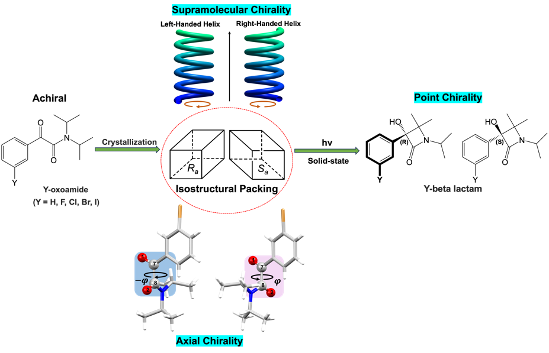

Figure 1. Hierarchical emergence of chirality in an isostructural series.

[1] Chem. Soc. Rev.,2017,46,7787-7839.

[2] CrystEngComm,2015,17,4421-4433

[3] J. PhotoChem.Rev.,2006,183–196.

