# Structural chirality and functionality in incommensurate modulated tetragonal tungsten bronzes

## O. Grendal1, C.R. Zeiger1, R.S. Dragland1, R. Sjøkvist2, R. Beanland2, D. Meier1, M. Senn3

### 1Department of Materials Science and Engineering, NTNU Norwegian University of Science and Technology, Sem Sælandsvie 12, 7491 Trondheim, Norway, 2Department of Physics, University of Warwick, Gibbert Hill Road, Coventry CV4 7AL, United Kingdom, 3Department of Chemistry, University of Warwick, Gibbert Hill Road, Coventry, CV4 7AL, United Kingdom

### Email of communicating ola.g.grendal@ntnu.no

Chirality is a crucial and fundamental concept in natural sciences having great implications in fields ranging from cosmology to particle physics, including chemistry, medicine and biology [1]. In solid-state physics chirality is closely linked to optical activity [2] and is gaining increasing interest due to topics like magnetic skyrmions [3], chiral quantum optics [4] and even enabling negative refraction and thus making of “perfect” lenses [5]. Following from this is a growing interest in direct external-field control of chirality, *i.e.* *ferrochirality*, as this would enable direct control of chirality-related phenomena and functionality. A ferrochiral material need to possess an achiral to chiral phase transition and show “switchable” chirality in the chiral phase. Such materials are rare, and an unambiguous direct switching of chirality has so-far not been demonstrated. However, promising work using laser radiation for controlling chirality have been performed [6].

Here we present an in-depth structural characterization of two new potential ferrochiral materials. The incommensurate modulated structure of the two tetragonal tungsten bronze materials K4Bi2Nb10O30 (KBN) and Rb4Bi2Nb10O30 (RBN) are solved, and their functional properties characterized. The incommensurate modulated structures are described by superspace group *P*4212(00γ)*q*00with an unusual helical displacement of Bi3+ atoms along the *c-*direction of the average cell, as shown in Fig. 1. *P*4212 is one of the 43 *non-enantiomorphic* Sohncke space group, and the structure is thus chiral due to the chirality of the Bi3+ helix in the structure. The order parameter of the achiral to chiral phase transition is shown to transform as the irreducible representation $Λ_{5}$ (*i.e.* the order parameter is the chirality itself), with a second order parameter transforming as $Γ_{1}^{-}$. The $Γ_{1}^{-}$ mode induces piezoelectricity, that we have experimentally verified. Finally, through group theory and invariant analysis, we propose that combining symmetry breaking share strain (transforming as $Γ_{5}^{+}$) and an electric field (transforming as $Γ_{5}^{-}$) can be used as a conjugate field to switch the chirality through its link with the piezoelectric properties of the materials. This would then be a way of demonstrating chiral switching and provide solid evidence for ferrochirality in these materials.

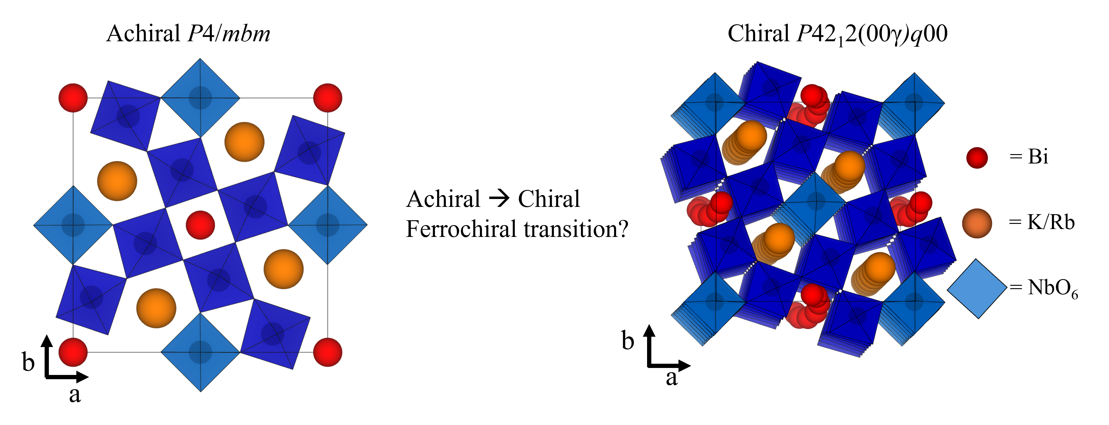

###### **Figure 1**. The achiral to chiral phase transition found in KBN and RBN.

#### [1] Bousquet, E.; Fava, M.; Romestan, Z.; Gómez-Ortiz, F.; McCabe, E. E. & Romero, A. H. (2025). *J. Phys. Condens. Matter*, **37**, 16.

#### [2] Glazer, A. M.; Stadnicka, K. (1986). *J. Appl. Crystallogr*. 1986, **19**, 2.

#### [3] Mühlbauer, S.; Binz, B.; Jonietz, F.; Pfleiderer, C.; Rosch, A.; Neubauer, A.; Georgii, R.; Böni, P. (2009). *Sci*., **323**, 5916.

#### [4] Lodahl, P.; Mahmoodian, S.; Stobbe, S.; Rauschenbeutel, A.; Schneeweiss, P.; Volz, J.; Pichler, H.; Zoller, P. (2017). *Nat*., **541**, 7638.

#### [5] Pendry, J. B. A. (2004). *Sci*., **306**, 5700.

#### [6] Hayashida, T.; Kimura, K.; Kimura, T. (2022). *J. Phys. Chem. Lett*., **13**, 17.