## Structure and coordination chemistry of some aminopyrazoles, 1,3-diazocanes, and fused dipyrazoloheterocycles

### **L.N. Dawe, 1 D. Joekar,1 K. Brown,1 L. Lobulo,1 D. Graham,1 K. Stephens,1**

### **P.D. Boyle, 2 and K. Maly1**

*1Department of Chemistry and Biochemistry, Wilfrid Laurier University, Waterloo, ON, Canada, 2Western University, Department of Chemistry, London, ON, Canada*

### ldawe@wlu.ca

We have previously reported ligand systems that simultaneously incorporate three types of molecular affinity: (i) coordination of Lewis acids; (ii) intermolecular interactions with anions; and (iii) additional functional modalities [1]. We have targeted this design strategy to tune the functional groups for interactions with specific cations and anions, for explorations into the directionality of weak intermolecular forces, which may be further complicated by the presence of stronger, competing forces.

In the case of our aminopyrazole systems (Fig 1), we have previously observed *via* polarized optical microscopy that all exhibit supercooling of between 34 and 100 oC, and upon coordination to ZnCl2 and ZnBr2, we have observed bright, solid-state fluorescence. Solid-state fluorescence has also now been observed for ligand systems where the amino-group has been transformed to both urea and thiourea functionalities. This fluorescence is quenched upon transition metal cation complexation. Fluorescence, ligand and complex structures, and Hirshfeld surface results have been analyzed and related to the extent of p-interactions in the solid state. We have recently undertaken theoretical studies to complement these experimental results.

Further, with an eye-towards advancing the incorporation of additional functionality, we have undertaken Schiff base reactions between our aminopyrazole systems and multiple aldehydes. While not unprecedented [2], these reactions yielded a plethora of unexpected 1,3-diazocanes and fused dipyrazoloheterocycles (Fig. 1). The coordination chemistry of these systems with first row transition metal cations has been explored. The structural characterization and spectroscopic properties of these ligands and their complexes will be presented.

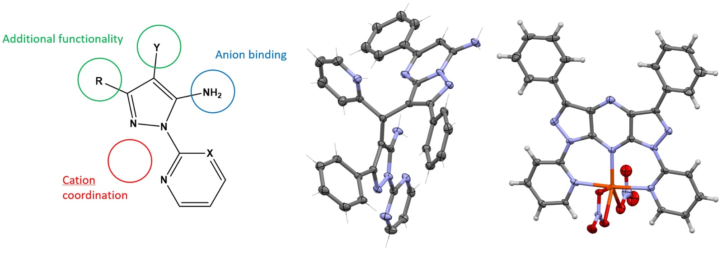

###### **Figure 1**. Multifunctional aminopyrazole systems, a 1,3-diazocane and a fused dipyrazoloheterocycle.

[1] Hiscock, L. K.; Joekar, D.; Balonova, B.; Tomas Piqueras, M.; Schroeder, Z. W.; Jarvis, V.; Maly, K. E.; Blight, B. A.; Dawe, L. N. Structures, Phase Behavior, and Fluorescent Properties of 3-Phenyl-1-(Pyridin-2-yl)-1*H*-Pyrazol-5-Amine and Its ZnCl2 Complex. *Inorganic Chemistry* **2019**, *58* (24), 16317–16321. <https://doi.org/10.1021/acs.inorgchem.9b02765>.

[2] Jiang, B.; Fan, W.; Sun, M.-Y.; Ye, Q.; Wang, S.-L.; Tu, S.-J.; Li, G. Domino Reaction of Arylglyoxals with Pyrazol-5-Amines: Selective Access to Pyrazolo-Fused 1,7-Naphthyridines, 1,3-Diazocanes, and Pyrroles. *J. Org. Chem.* **2014**, *79* (11), 5258–5268. <https://doi.org/10.1021/jo500823z>.