## Are crystal structures getting better? A statistical analysis of the Cambridge Structural Database

## F. Meurer1

### 1University of Regensburg, Universitätsstr. 31, 93053 Regensburg, Germany

### florian.meurer@ur.de

Since 1965, the Cambridge Structural Database (CSD, [1]) has collected roughly 1.3 million crystal structures of organic and metalorganic chemical compounds. The immensely improved capabilities of modern X-ray technology today, compared to when the CSD started, suggest that crystal structures should have also improved since then. Model improvements by e.g., the introduction of anisotropic displacement parameters [2] and the introduction of quantum crystallographically improved atomic form factors [3], further support this assumption.

On the other hand, by these new advances, the space of “measurable” crystals has also drastically extended, including inherently problematic structures such as metal-organic frameworks, where weakly ordered solvents are omnipresent. Furthermore, the increased automation paired with modern X-ray devices makes it easier for novices to measure and interpret a crystal structure and extends the room for “rookie mistakes” being deposited in the databases. Even though there are routine validation services [4], mistakes can and will always happen. Finally, automation also puts a larger burden on X-ray facilities, reducing the available time per crystal structure with an “exponential” increase in yearly crystal structures, but decreasing personnel employed for structural analysis.

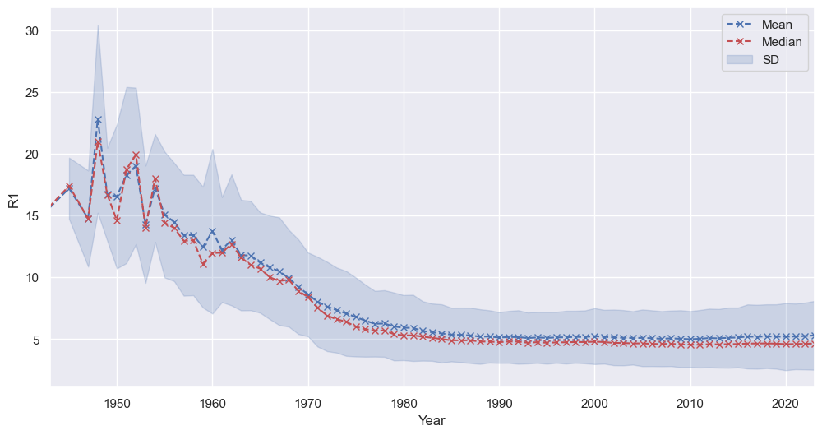

###### **Figure 1**. Yearly mean and average R1 value for the structures deposited in the Cambridge Structural Database.

Figure 1 shows the average and mean annual R1 values for structures deposited in the CSD since its beginning. In my talk, I want to discuss the statistics behind data quality in the CSD, what factors should also be considered, and whether we can see a positive or negative trend regarding the title question.

[1] Groom, C. R., Bruno, I. J., Lightfoot, M. P., Ward, S. C. (2016) *Acta Cryst.* B72, 171-179.

[2] Cruickshank, D. W. J. (1956) *Acta Cryst.* **9**, 747–753.

[3] Coppens, P., Hansen, N. K. (1978) *Acta Cryst*. **A34**, 909–921.

[4] Spek, A.L. (2003) *J. Appl. Cryst.* **36**, 7-11.

I am grateful for funding from the Studienstiftung des Deutschen Volkes e.V. for a scholarship for my Ph.D.