# Naphthyridine carbamate dimer ligand induces formation of Z-RNA-like fold of disease-related RNA and serves as a molecular glue for crystal lattice formation

## M. Mateja-Pluta1, A. Kiliszek1

### 1Institute of Bioorganic Chemistry Polish Academy of Sciences, Noskowskiego Street 12/14, Poznan

### mpluta@ibch.poznan.pl

RNA molecules are pivotal players in diverse cellular processes and the pathogenesis of human diseases. Messenger RNA (mRNA) serves as a conduit for genetic information transfer from DNA to proteins, facilitated by ribosomes and transfer RNAs (tRNAs). Various small RNA molecules, including small nuclear RNAs (snRNAs), microRNAs (miRNAs), and small interfering RNAs (siRNAs), regulate gene expression through mechanisms like splicing, degradation, or translational inhibition. Ribozymes, or catalytic RNAs, play roles in RNA cleavage or ligation across different organisms [1,2].

RNA emerges as an attractive therapeutic target for neurological disorders, given its involvement in diverse disease mechanisms. Small molecules offer advantages over antisense oligonucleotides, particularly in disorders involving repeat expansions like fragile X syndrome and Huntington's disease [3].

The Nakatani research team's methodologies, utilizing screening assays, have identified promising small molecules, exemplified by naphthyridine, which exhibits robust affinity for G-rich RNA sequences. This molecule shows potential in addressing conditions such as spinocerebellar ataxia type 31, binding to specific RNA structures with high specificity and inducing structural alterations crucial for disease onset [4].

In this study, we present the structural analysis of the NCD ligand bound to RNA containing the UGGAA/UGGAA motif associated with spinocerebellar ataxia type 31 (SCA31). We characterized two crystal structures of RNA-ligand complexes, along with a previously unreported structure of RNA without ligand binding. Our findings elucidate that the NCD ligand is positioned between RNA molecules related by symmetry, contributing additional interactions within the crystal lattice. This highlights the potential of the NCD ligand as a molecular glue to facilitate crystal formation.

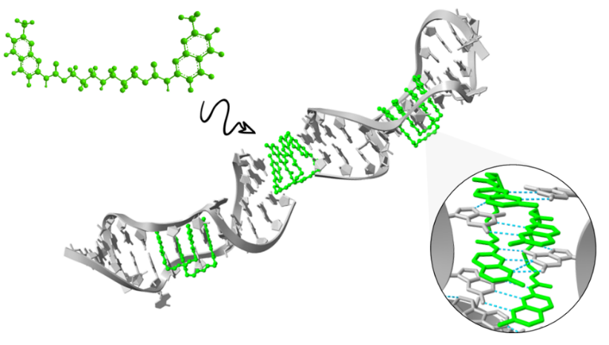

###### **Figure 1**. RNA-NCD ligand complex.

#### [1] C.M. Conelly, et al., Cell. Chem. Biol., 23 (2016)

#### [2] G.J. Goodall et al. Nat. Rev. Cancer 21, (2021)

#### [3] F. Hamy et al., Biochemistry, 94 (1997) 3548

#### [4] T. Shibata, et al., Nat. Commun., 12, (2021) 236

Funding: National Science Centre, Poland; GRANT NO. UMO-2017/26/E/NZ1/00950

National Science Centre, Poland; GRANT NO. UMO-2022/45/B/NZ7/03543