# Real-time observation of ultra-rapid densification and degradation in flash sintered monolithic all-solid-state batteries

## Riku Fukada1, Timothée Fabre2, Eduardo Rodrigues Gonçalves2, Philip Chater3,

## Renaud Bouchet2, Marlu César Steil2, Claire V. Colin1, Maria Diaz-Lopez1

*1Institut Néel, Université Grenoble-Alpes, CNRS, Grenoble, France, 2LEPMI, University Grenoble Alpes, CNRS, Grenoble INP, Grenoble, France, 3Diamond Light Source Ltd., Didcot, UK.*

With increasing demand for advanced energy storage, cost-effective and efficient production of all-solid-state batteries (ASSBs) is critical for sustainable, low-waste energy solutions. ASSBs offer enhanced safety, higher energy density, and improved durability due to their solid electrolytes. However, conventional fabrication methods are costly, energy-intensive, and often yield poor interfacial contact, limiting commercial scalability. Advanced sintering techniques such as spark plasma sintering (SPS), cold sintering (CS), and flash sintering (FS) have emerged as promising alternatives. Flash sintering, in particular, significantly reduces sintering times from hours to seconds and greatly lowers energy consumption, aligning with circular economy principles.[1]

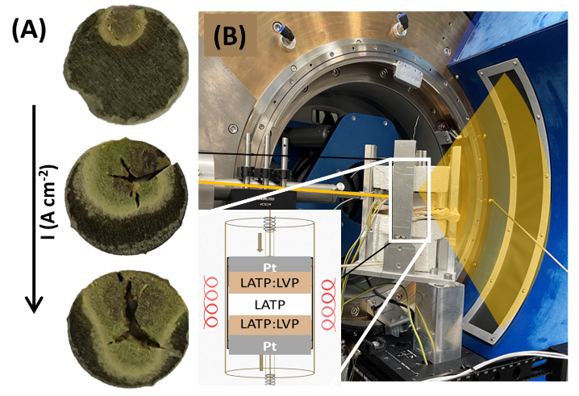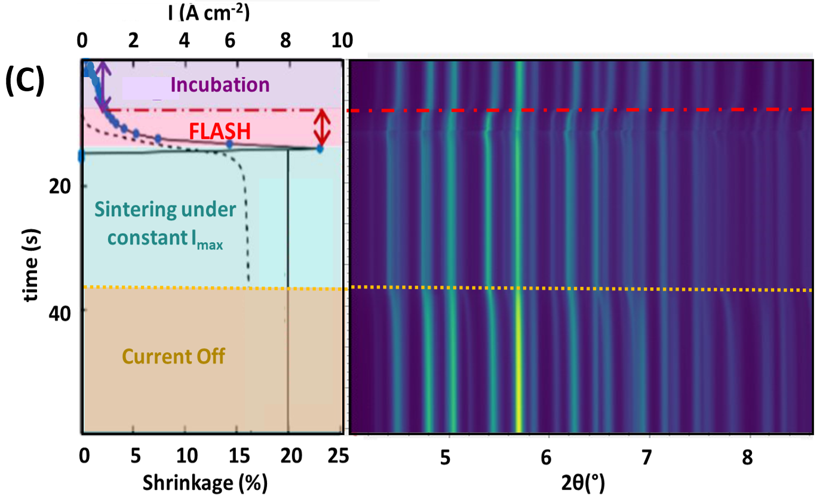

###### **Figure 1**. (A) Hotspot formation in LVP as a function of with current intensity (2, 6, and 9 A/cm²; 50s, 1kHz). (B) In situ EFS set-up at the i15-1 beamline of the Diamond Light Source with the new ARC detector featuring sub-millisecond temporal PDF resolution. The adapted DRIX cell is housed in a custom designed heater to simulate flash conditions.[2] The X-ray beam is indicated in yellow and the inset provides a schematic of the cell in the heater. (C) Left: Stages of the isothermal flash sintering. The black solid and dotted lines represent the current and sample shrinkage, respectively. Right: In-situ XRD of the LATP region of the Multilayer.

In this study, we explore the fundamental mechanisms of ultra-rapid sintering in flash-sintered, self-supported monolithic ASSBs composed of a Li₁.₄Al₀.₄Ti₁.₆(PO₄)₃ (LATP) electrolyte and Li₃V₂(PO₄)₃ (LVP):LATP composite electrodes. Using total scattering (Bragg + Pair Distribution Function), we spatially mapped structural changes to capture the formation of hotspots—localized areas of intense Joule heating causing particle cracking, phase decomposition, and amorphization(**Fig. 1(A)**). These inhomogeneities underscore the complexity of field-assisted sintering, where densification and decomposition occur simultaneously at sub-second timescales. To investigate these ultrafast transformations, we performed in-situ total scatteringmeasurements using the newly commissioned ARC detector of the i15-1-Diamond beamline, achieving millisecond temporal resolution(**Fig. 1(B)**). This allowed us to directly observe both local and mesoscale structural dynamics during the sintering pulse. Capturing the instantaneous formation of an amorphous intermediate, which subsequently crystallizes within seconds, offering new insights into transient states previously inaccessible(**Fig. 1(C)**). Together, these findings provide spatial and temporal insight into how rapid, localized heating in flash sintering drives densification, interfacial reactions, and degradation in ASSLBs. Our use of ultra-fast total scattering reveals transient structural states, laying the groundwork for understanding reaction fronts and interfaces across broader materials systems and applications.

#### References :

#### [1] Lachal, M., El Khal, H., Bouvard, D., Chaix, J.-M., Bouchet, R. & Steil, M. C. (2021). Journal of the American Ceramic Society 104, 3845–3854.

#### [2] Diaz-Lopez, M., Cutts, G. L., Allan, P. K., Keeble, D. S., Ross, A., Pralong, V., Spiekermann, G. & Chater, P. A. (2020). J Synchrotron Rad 27, 1190–1199.