## Reproducible Electron Diffraction Simulations: Bridging Bloch Wave and Multislice Simulations with abTEM

### **M. K. Cabaj1, P. B. Klar2, J. Madsen3, M. Kaur3, T. Susi3, L. Palatinus1**

### 1Institute of Physics of the CAS, Prague, Czechia, 2Department of Geosciences at the University of Bremen, Bremen, Germany, 3Faculty of Physics, University of Vienna, Vienna, Austria

### mkcabaj@fzu.cz

We introduce a computational pipeline built with *abTEM*[1], a Python-based package, for simulating electron diffraction patterns across arbitrary crystal orientations and rotational scans, closely replicating transmission electron microscope capabilities. This framework offers key advantages, like cost efficiency, reproducibility, precise parameter control, and freedom from experimental constraints.

The pipeline takes a CIF and user-defined parameters to simulate diffraction patterns under realistic experimental conditions. For the multislice calculations, supercells are generated at multiple orientations and sample thicknesses by rotating the crystal around a specified axis and replicating the unit cell accordingly. The Bloch wave method employs the standard approach, using the original unit cell without the need for supercell generation or thickness variation. To validate the pipeline, we systematically compared diffraction intensities from the Bloch wave and multislice methods—two theoretically equivalent but, under certain conditions, numerically divergent approaches. Using a benchmark silicon (Si) structure, we analysed key factors affecting convergence, including sample thickness, crystal orientation, symmetry-related effects, unit cell size and the impact of atomic substitution.

We found that for sufficiently thick samples, the average R-factor between the two methods stabilized at around 1.25%, which we consider to be a very good match. In contrast, thinner samples exhibited higher R-factors due to insufficient scattering for reliable comparison. To isolate the effect of atomic number (Z) on the accuracy of the simulation, we substituted silicon atoms with chemically similar group IV elements. We observed a steady increase in R-factors with heavier atoms, which we attribute to the increased sensitivity of simulations to numerical parameters when high-Z elements are involved. Finally, we explored the effect of unit cell size by scaling the Si structure while maintaining atomic composition and symmetry. As the cell size decreased and density increased, R-factors rose consistently. This suggests that in denser materials, stronger multiple scattering introduces greater discrepancies between the two formalisms, highlighting their sensitivity to both structural parameters and computational settings.

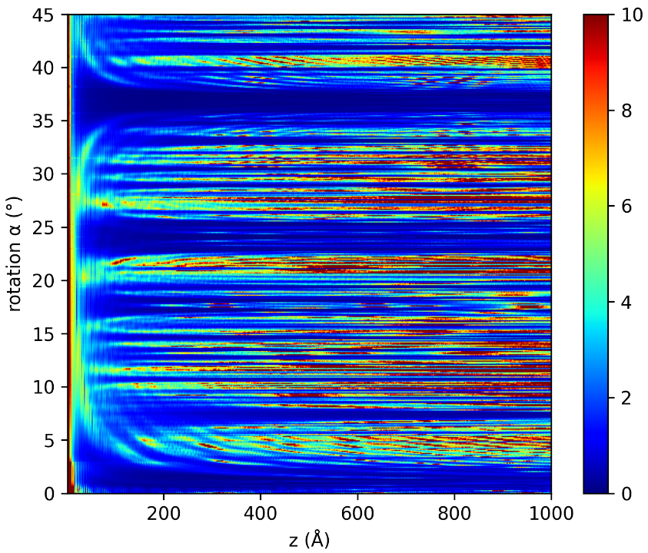

###### **Figure 1**. R-factor between intensities obtained with Bloch wave and multislice approach, for different thicknesses and sample orientations for Si structure.

#### [1] Madsen, J. and Susi, T. "The abTEM code: transmission electron microscopy from first principles" [version 2; peer review: 2 approved]. *Open Res Europe* 2021, 1:24.

This work was funded by the Czech Science Foundation, Grant No. 21-05926X.