# Aperiodic order and complex superstructures from simple algebraic rules

## W. Hornfeck

### FZU - Institute of Physics of the Czech Academy of Sciences, Na Slovance 1999/2, 182 00 Prague 8, Czechia

### hornfeck@fzu.cz

In my talk I would like to give a short survey about how structural complexity in some special cases can be understood by simple rules. These rules are algebraic in nature and thus very much different from the usual description of crystal structures by space group symmetry. They follow the idea of a more algorithmic understanding of crystal structures, such that the structural complexity can be understood in the sense of Kolmogorov, namely as the shortest possible program that is able to generate the crystal structure. On the way one will encounter pseudorandom and quasirandom numbers, integer and rational sequences, time-quasicrystals and twin-quasilattices (Figure 1), and also turtles familiar with geometry.

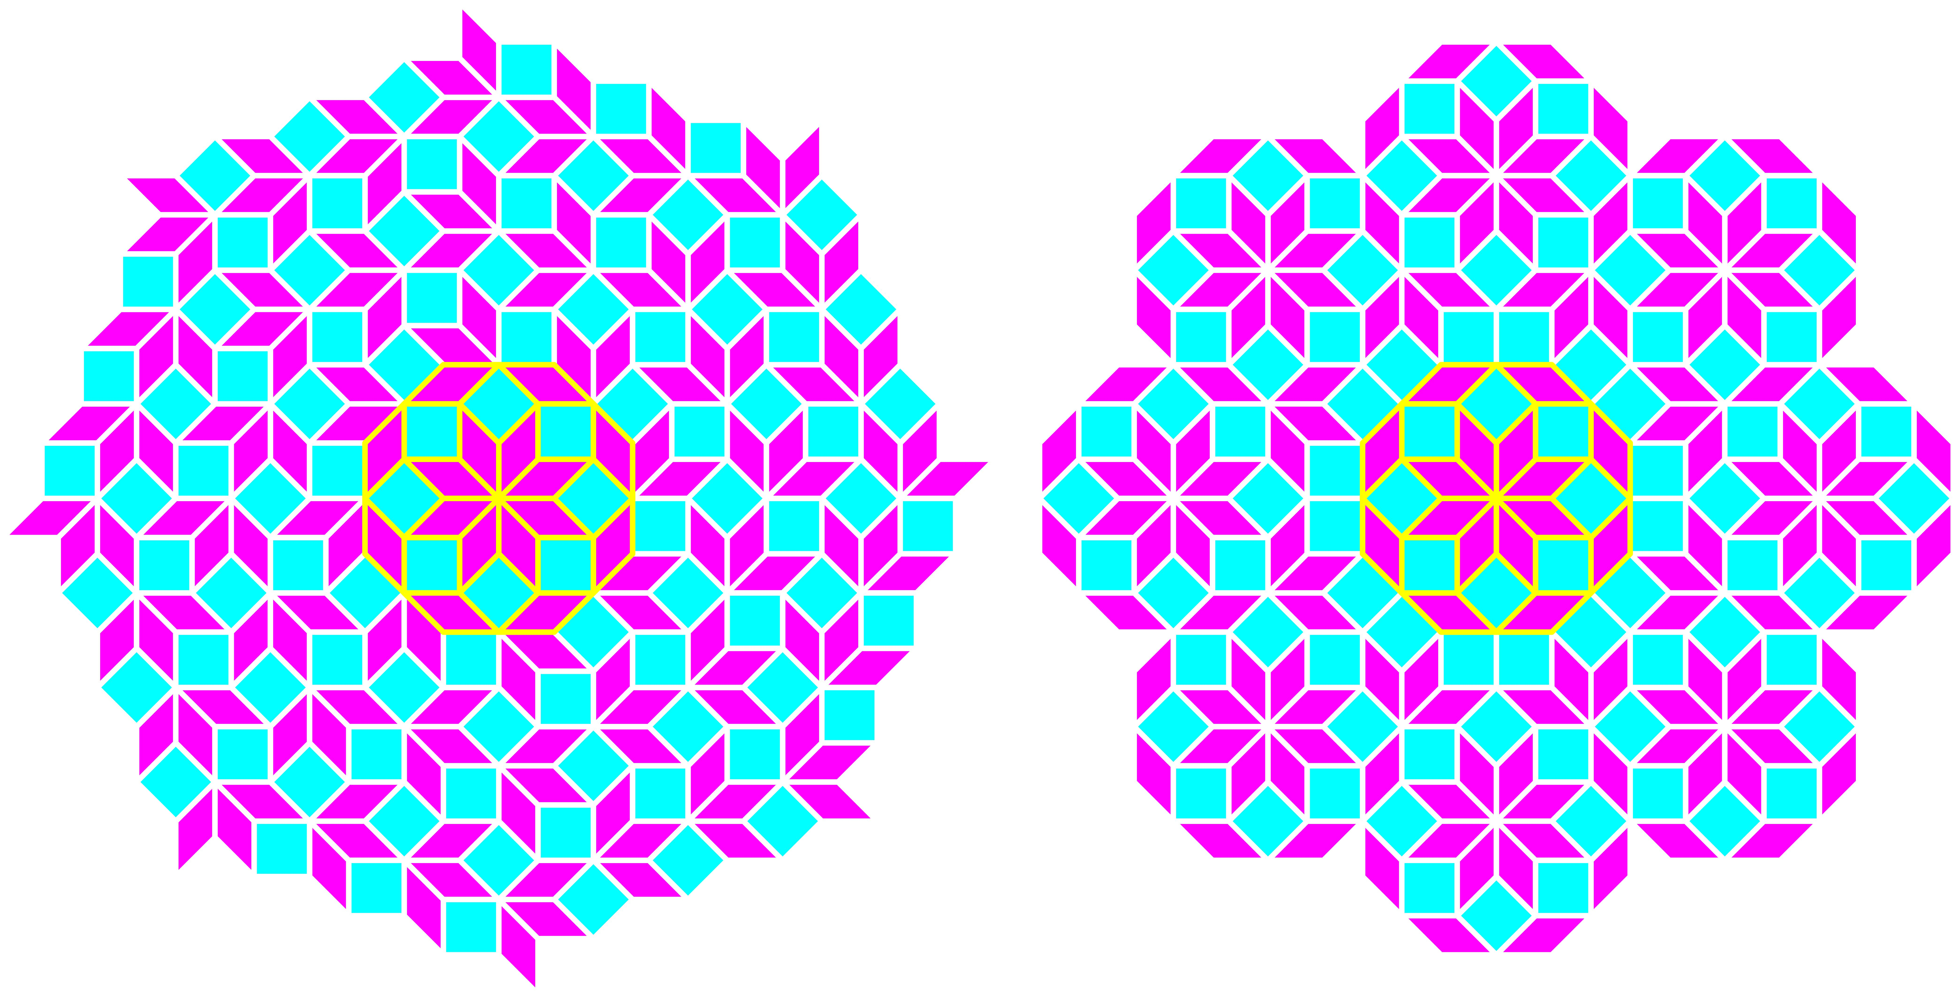

###### **Figure 1**. Eightfold chiral spiral cyclic twin versus Ammann-Beenker quasiperiodic pattern.

Examples of actual crystal structures will be taken from the realm of intermetallic compounds, in particular from the binary systems Ir-Zn, Na-Hg, Ni-Zr, and Ir-V. In order to make the exposition of abstract ideas a little easier, I will focus almost exclusively on (2+1)-dimensional crystal structures, in the sense that the structures under investigation can be understood by planar sections and projections, in which the structural complexity and the aperiodic order is predominantly restricted to a two-dimensional subspace, while the structures are periodic in the third, perpendicular direction.

#### [1] Hornfeck, W., Harbrecht, B. (2009). *Acta Cryst. A* **65**, 532-542.

#### [2] Hornfeck, W. (2012). *Acta Cryst. A* **68**, 167-180.

#### [3] Hornfeck, W. (2013). *Acta Cryst. A* **69**, 355-364.

#### [4] Hornfeck, W., Kuhn, P. (2014). *Acta Cryst. A* **70**, 441-447.

#### [5] Hornfeck, W., Hoch, C. (2015). *Acta Cryst. B* **71**, 752-767.

#### [6] Hornfeck, W. (2020). *Acta Cryst. A* **76**, 534-548.

#### [7] Hornfeck, W. (2023). *Acta Cryst. A* **79**, 570-586.

I wish to thank Michal Dušek for his continuous endorsement of my research.