# Atomic-level mechanism underlying elastic flexibility of coordination polymer crystals

## M. Đaković

### 1University of Zagreb, Faculty of Science, Horvatovac 102A, 10000 Zagreb, Croatia

### mdjakovic@chem,pmf.hr

The emergence of mechanically adaptive crystals to various external stimuli—such as heat, light, and mechanical force—has garnered significant attention over the past few decades due to their remarkable potential across a wide range of advanced applications, spanning from optical waveguiding and (semi)conductivity to wearable devices and soft robotics [1]. While the promise of these materials is undeniable, a deeper understanding of fundamental mechanisms underlying their exceptional flexibility is essential for their effective integration into innovative devices. Recently, we explored several families of mechanically flexible crystals of 1D coordination polymers (CPs) and reported on their exceptional adaptive potential and the impact of intermolecular interactions on the delivery of a wide range of mechanical responses, from pronounced pliability to exceptional elasticity [2-6]. To enhance our understanding of the adaptive behaviour of these materials, we aim to uncover the mechanisms behind their bending capabilities and explore the impact of intermolecular interactions on crystal dynamics.

Therefore, in this contribution, we primarily focus on two novel 1D coordination polymers, [Cd(μ-X)2L2]*n* (X = Cl, Br; L= pyrazinamide), which exhibit mechanically stimulated 2D anisotropic elastic flexibility. Alongside an extensive exploration of their elastic properties – utilising three-point bending, AFM, and computational methods, where the isostructurality of the two materials provided crucial insights – our primary emphasis was on the atomic-level changes that occur under mechanically induced bending conditions. By mapping the structural alterations across the apex of the bent crystal, using micro-focus synchrotron radiation, we were able to present *the first mechanism of elastic bending* in coordination polymer crystals. The mechanism is notably distinct from the elastic mechanisms reported so far, such as elastically flexible molecular crystals under mechanical stress and 1D plastically deformable crystals under quasi-hydrostatic pressure. When subjected to mechanical stress, both the 1D structural spine and the ligands themselves adapt to changes in external conditions – while the polymeric spines exhibit spring-like mobility, the ligands themselves rotate towards linearity with the bending face (i.e. reducing the *θ* angle; see Figure 1). Moreover, through an integrated approach that combines experimental findings with computational efforts, we were also able to deliver direct connections between the relative degree of structural changes along the axes associated with the bending faces and the relative strength of the weakest intermolecular links as well as crystal stiffness (*E*) influencing these particular directions – the weaker the supramolecular connectivity, the more susceptible crystal structure to atomic-level adjustments [7].

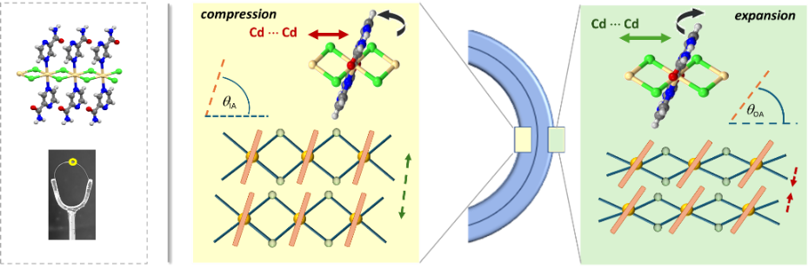

###### **Figure 1**. The atomic-level changes at the compression and expansion side materialising upon elastic bending of 1D coordination polymer crystal of Cd(II), [CdCl2(pza)2]*n*, deduced by μ-SCXRD synchrotron mapping experiments.

#### [1] Wei, C., Li, L., Zheng, Y., Wang, L., Ma, J., Xu, M., Lin, J., Xie, L., Naumov, P., Ding, X., Feng, Q. & Huang, W. (2024) *Chem.Soc.Rev.* **53**, 3687.

#### [2] Đaković, M., Borovina, M., Pisačić, M., Aakeröy, C. B., Soldin, Ž., Kukovec, B.-M. & Kodrin, I. (2018) *Angew. Chem. Int. Ed.* **57**, 14801.

#### [3] Pisačić, M., Biljan, I., Kodrin, I., Popov, N., Soldin, Ž. & Đaković, M. (2021) *Chem. Mater.* **33**,3660.

#### [4] Pisačić, M., Kodrin, I., Biljan, I. & Đaković, M. (2021) *CrystEngComm* **23**,7072.

#### [5] Pisačić, M., Kodrin, I., Trninić, A. & Đaković, M. (2022) *Chem. Mater.* **34**,2439.

#### [6] Mišura, O., Pisačić, M., Borovina, M. & Đaković, M. (2023) *Cryst. Growth Des.* **23**, 1318.

#### [7] Đaković, M., Pisačić, M., Borovina, M., Kodrin, I., Kenđel, A. & Frey, T., *JACS*, *accepted.*

This work has been fully supported by the Croatian Science Foundation under Project IP-2019-04-1242. We gratefully acknowledge the Paul Scherrer Institut, Villigen, CH, for the provision of synchrotron radiation beamtime at beamline X06SA (PXI) at the SLS.