# Photomechanical motions in organoboron crystals featuring topochemical reactivity and phosphorescence emission

## Subhrajyoti Bhandary*1, Anna M. Kaczmarek2, and Kristof Van Hecke1

### 1 XStruct, Department of Chemistry, Ghent University, Krijgslaan 281-S3, 9000 Ghent, Belgium

### 2 NanoSensing Group, Department of Chemistry, Ghent University, Krijgslaan 281-S3, 9000 Ghent, Belgium

### Email: Subhrajyoti.bhandary@ugent.be; <https://www.xstruct.ugent.be>

Molecular single crystals which respond to different external stimuli (heat, light, magnetic field, mechanical force etc.), have promising applications in the development of next-generation smart materials. [1, 2] Recently, the transduction of thermal/light energy into various macroscopic mechanical motions (such as bending, splitting, and popping/jumping effects) in molecular single crystals has emerged at the forefront of research. Among various stimuli, light is the most preferable in terms of remotely controllable actuation. [3] In particular, the rapid transformation of light energy (photon) into mechanical motions in densely packed metal-free luminescent crystals offers a sustainable choice of *smart ordered materials* for lightweight actuating and all-organic photonic devices. [4] However, the integration of rapid photodynamic motions and room temperature phosphorescence (RTP) emission in molecular crystalline materials is seldom known.

Here, I present a new class of molecular organoboron-based Lewis acid-base type crystals, which exhibit prompt photodynamic effects (ballistic splitting, moving, and jumping motions or *photosalient effect*) under ultraviolet (UV) to green-energy visible light/solar energy (Fig. 1). [5-7] Moreover, the mechanical motions (second scale) in such photoresponsive materials are associated with topochemical [2+2] cycloaddition reactions in the *single-crystal-to-single-crystal* (SCSC) fashion. Remarkably, these organoboron crystals also display dynamic RTP features as their emission peaks/intensities promptly change due to photomechanical effects and SCSC reactions. These results disclose the potential of dynamic organoboron crystals to be exploited as *energy-transforming* and *phosphorescent smart materials*.

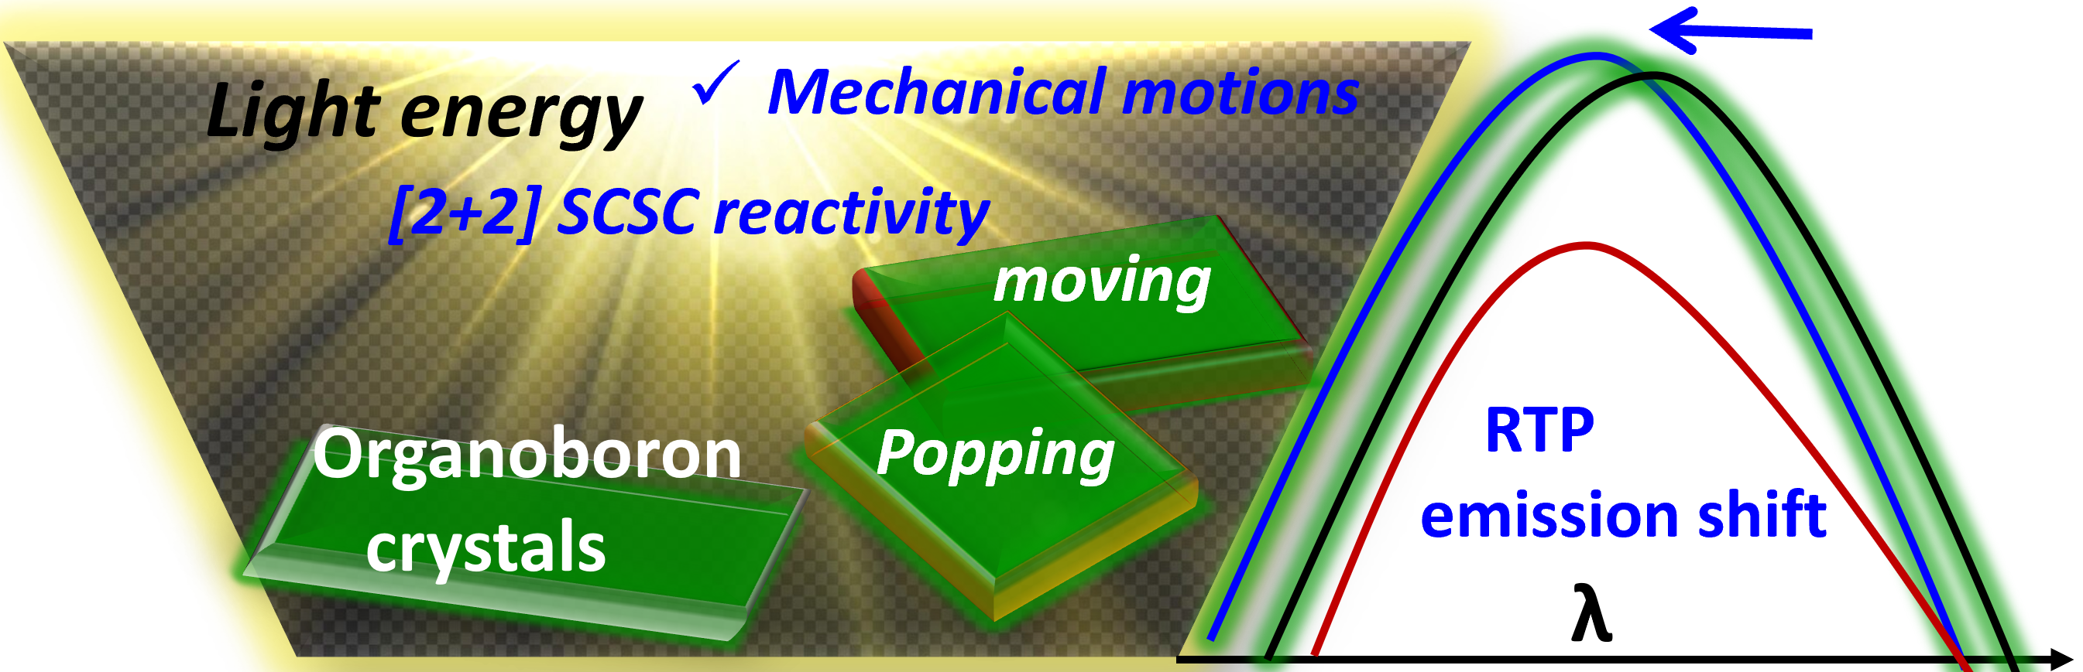

**Figure 1**. Different photomechanical motions in organoboron single crystals in response to UV or visible light source.

[1] Bhandary, S., Van Deun, R., Kaczmarek, A. M. & Van Hecke, K. (2022). *Chem. Sci*. **12**, 15423.

[2] Naumov, P., Karothu, D. P., Ahmed, E., Catalano, L., Commins, P., Halabi, J. M., Al-Handawi, M. B. & Li, L. (2020). *J. Am. Chem. Soc*., **142**, 13256.

[3] White, T. J. (2017). *Photomechanical Materials, Composites, and Systems: Wireless Transduction of Light into Work*, Wiley, Hoboken.

[4] Irie, M., Fukaminato, T., Matsuda, K. & Kobatake, S. (2014). *Chem. Rev*., **114**, 12174.

[5] Bhandary, S., Beliš, M., Kaczmarek, A. & Van Hecke, K. (2022). *J. Am. Chem. Soc*., **144**, 22051.

[6] Bhandary, S., Beliš, M., Bourda, L., Kaczmarek, A. & Van Hecke, K. (2023). *Angew. Chem. Int. Ed*., **62**, e202304722.

[7] Bhandary, S., Beliš, M., Shukla, R., Bourda, L., Kaczmarek, A. & Van Hecke, K. (2024). *J. Am. Chem. Soc.*, **146**, 8659.

We acknowledge the Research Foundation - Flanders (projects AUGE/11/029 and 1275221N) and Special Research Fund (BOF)–UGent (project BOF/24J/2023/084) for funding.