# pyDiSCaMB: enabling the use of multipolar scattering factors in Phenix

## V. J. Femoen1, L. Pacoste1, D. Liebschner2, P. Afonine2, B. Poon2, M. Chodkiewicz3, P. Dominiak3, X. Zou1

### 1Department of Chemistry, Stockholm University, Stockholm, Sweden, 2Molecular Biophysics and Integrated Bioimaging Division, Lawrence Berkeley National Laboratory, Berkeley, CA, USA, 3Biological and Chemical Research Center, Faculty of Chemistry, University of Warsaw, Warsaw, Poland

### viljar.femoen@su.se

Multipolar scattering factors expand upon the established Independent Atom Model (IAM) used when calculating scattering factors in Phenix [1]. The DiSCaMB software library [2] was written with multipolar scattering in mind, and supports e.g. Transferrable Aspherical Atom Model (TAAM) and Hirshfeld Atom Refinement (HAR). However, as Phenix is written in a mix of Python and C++, and Discamb is written independently in C++, multipolar calculations with DiSCaMB have thus far remained unavailable in Phenix.

To facilitate integration with Phenix, we developed pyDiSCaMB, a Python wrapper for DiSCaMB. This wrapper is designed to interface with *cctbx*, the underlying library of Phenix. pyDiSCaMB can be used as a standalone library, but its implementation within *cctbx* lets users leverage the extensive toolkit available for e.g. structure refinement. As an example, the control flow when using *phenix.refine* with pyDiSCaMB as the backend for TAAM structure factor calculations is presented in Fig. 1, showing how pyDiSCaMB acts as a translation layer between the two libraries. Developer versions of *cctbx* and Phenix already support TAAM calculations via pyDiSCaMB, and will soon be publicly available.

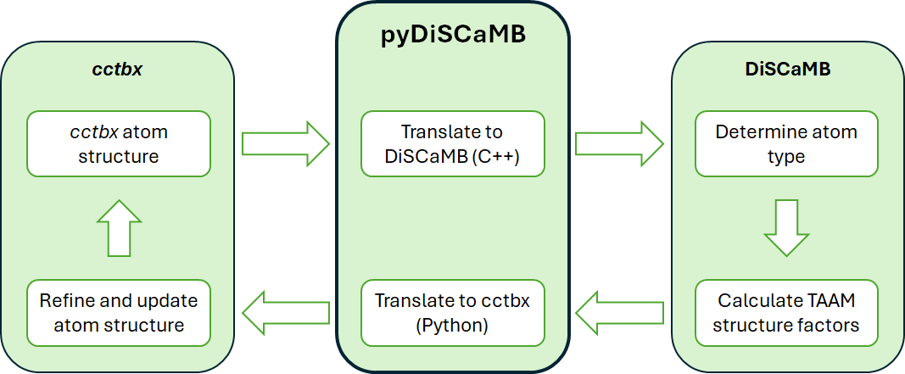

###### **Figure 1**. Control flow when running *phenix.refine* with TAAM scattering factors using pyDiSCaMB.

#### [1] Adams, P. D., Afonine, P. V., Bunkoczi, G., Chen, V. B., Davis, I. W., Echols, N., Headd, J. J., Hung, L.-W., Kapral, G. J., Grosse-Kunstleve, R. W., McCoy, A. J., Moriarty, N. W., Oeffner, R., Read, R. J., Richardson, D. C., Richardson, J. S., Terwilliger, T. C. & Zwart, P. H. (2010). Acta Cryst. **D66**, 213-221.

#### [2] Chodkiewicz, M. L., Migacz, S., Rudnicki, W., Makal, A., Kalinowski, J. A., Moriarty, N. W., Grosse-Kunstleve, R. W., Afonine, P. V., Adams, P. D. & Dominiak, P. M. (2018). *J Appl Cryst* **51**, 193–199.