# Bridging the gap: Investigating pharmaceutical hydrates through solution spectroscopy

## Benjamin Vella1, Katharina Edkins1

### 1Strathclyde Institute of Pharmacy and Biomedical Sciences, University of Strathclyde, 161 Cathedral Street, G4 0RE, Glasgow, UK

### Email of communicating author: katharina.edkins@strath.ac.uk

Many pharmaceutical drugs are delivered in solid preparations, often as crystalline forms.[1] The formation of drug hydrates raises concerns in the pharmaceutical industry, due to typically lower water solubility and bioavailability than their anhydrous counterparts. As a result, understanding the factors influencing hydrate formation is crucial for pharmaceutical research. In particular, the aggregation of drug and water molecules in the pre-crystallisation solution can play a key role in the subsequent formation of the crystal hydrate.

In this work, we present NMR and FTIR spectroscopic data which has been used to characterise and quantify the interactions between paracetamol (PCM) and water in solution. Titration of PCM with water leads to changes in the chemical shifts in the PCM 1H-NMR spectrum (Fig. 1). We fit the titration data to a binding equilibrium model which supports the presence of strong interactions between PCM and H2O in solution, correlating well with two previously reported paracetamol hydrates.[2]

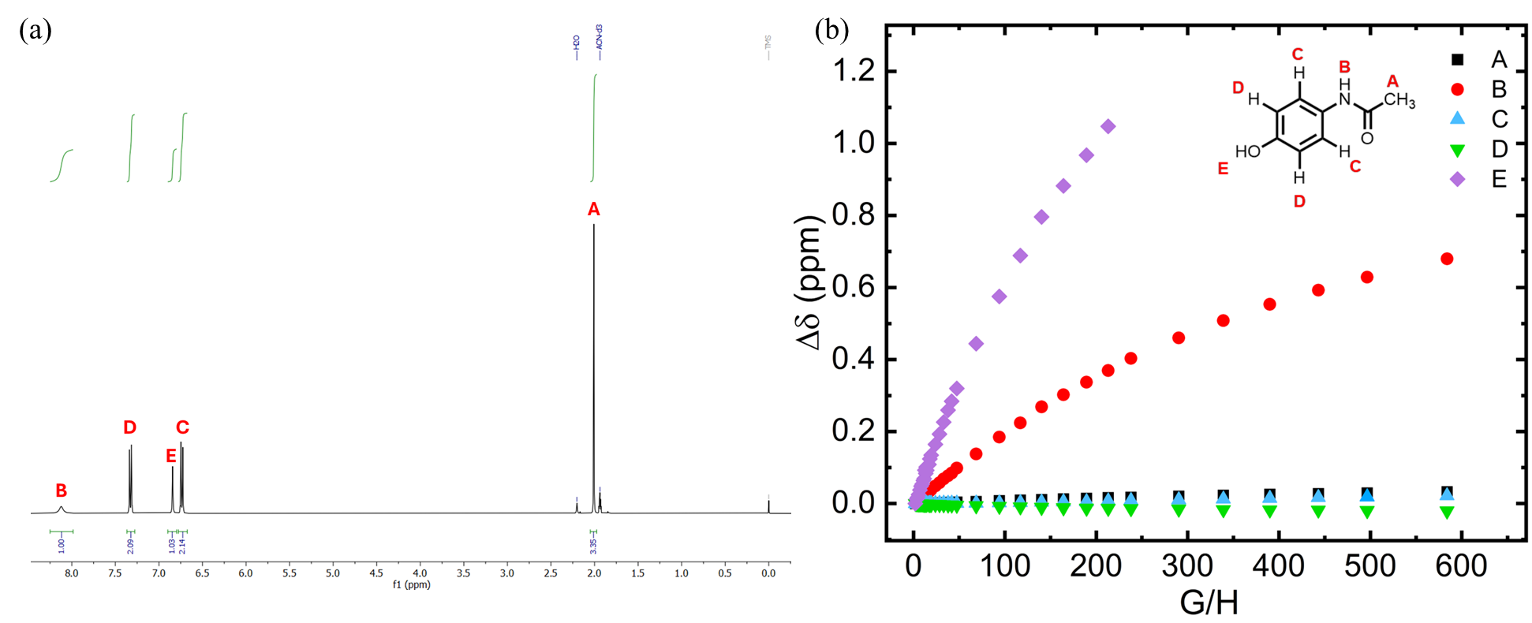

###### **Figure 1** (a) 1H-NMR spectrum of paracetamol in acetonitrile-d3. (b) 1H-NMR peak shift data of the PCM/H2O titration, showing the greatest shifts in the NH and OH protons. Here, G/H signifies equivalents of water added to the PCM solution.

Comparing FTIR and 1D-NOESY data with the reported crystal structures, we can also identify the changes in hydrogen bonding patterns upon moving from solid to solution states.

#### [1] B. Y. Shekunov and P. York, J. Cryst. Growth, 2000, 211, 122–136.

#### [2] P. A. McGregor, D. R. Allan, S. Parsons and C. R. Pulham, J. Pharm. Sci., 2002, 91, 1308–1311.