Form VI of Piracetam, the predicted yet elusive phase

M. E. Nowak¹, A. Lanza², A. Ø. Madsen³, M. Malinska¹, K. Syty¹, M. Modrzejewski¹, A. A Hoser¹

¹ Faculty of Chemistry, University of Warsaw, Pasteura 1 02-093 Warsaw
² Department of Chemistry, University of Copenhagen, Universitetsparken 5, 2100 Copenhagen Ø
³ Department of Pharmacy, University of Copenhagen, Universitetsparken 2, 2100 Copenhagen Ø

me.nowak8@student.uw.edu.pl

Polymorphs are "a solid crystalline phase of a given compound resulting from the possibility of at least two different arrangements of the molecules."^{[1]} Different polymorphic forms can exhibit varying physicochemical properties and bioavailability. For active pharmaceutical ingredients (APIs), selecting the appropriate form is crucial to maximize drug efficacy and reduce adverse effects. Thus, it is vital to know all of APIs polymorphic forms and their relative stabilities. Therefore, the rigorous process—including experimental screening and computational techniques like crystal structure prediction (CSP)—is essential to prevent issues like the Ritonavir case,^{[2]} where the appearance of new stable polymorph halted production for years.
Piracetam is a well-known, small molecule API, used in many studies as a model compound. Prior to 2022 ^{[3]} structures of five piracetam polymorphs were known. Form I, II and III are accessible in ambient pressure. Form IV is a high pressure structure and its discovery was the starting point for CSP ^{[4]} in search of other high pressure structures, which culminated in almost concurrent prediction and discovery of the form V of piracetam.
In 2022 Kakkar et al. ^{[3]} characterized a new (VI) phase based on X-ray powder diffraction, however the structure of this form remains unknown. Despite many crystallization attempts, we were unable to obtain crystals suitable for single crystal X-ray diffraction measurements. Therefore, we revert to 3D ED, and with this technique we attain the structure of form VI from crystalline powder. The form VI of piracetam crystallizes in space group P2₁/c (a = 6.444(5)Å, b = 6.443(4)Å, c =16.494(5)Å, β = 98.41(4)°) and its packing is similar to forms II and III. Packing of all three forms is based on the same double layer motif formed via hydrogen bonding between amide groups from neighbouring piracetam molecules. However, the layers are oriented differently in all three forms (see Fig 1).
Additionally, to understand the relative stability of this system we conducted a number of periodic DFT calculations^{[5,6]} and fragment-based coupled-cluster calculations. ^{[7]} The lattice energy of form VI is only slightly higher than forms II and III - those differences are in the limits of accuracy of DFT methods. To take into account vibrational contributions to free energy, we calculated frequencies at Gamma point and conducted normal mode refinement ^{[5]}.The calculated free energies for polymorphs at room temperature show the order of stability III > II ≥ VI > I which correspond with those found in literature. ^{[8]}
Interestingly, the structure of form VI overlaps with previously predicted with CSP low energy structure of piracetam. ^{[4]} This shows, that, in some cases, structures that have been obtained from CSP but have not yet been experimentally observed(or isolated) are not necessarily a case of overprediction –sometimes we just need to conduct the right experiment.

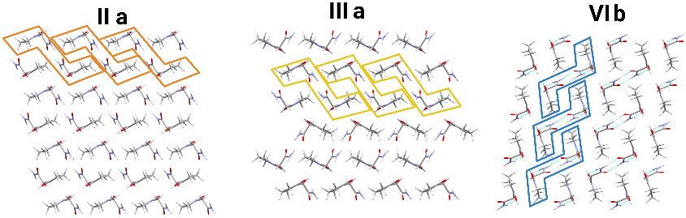

Figure 1. Comparison of packing in Piracetam polymorphs, the molecules are packed in double layer made with marked dimers.
[1] Fox, D.; Labes, M. M.; Weissberger, A.; Rice, S. A. Physics Today 1965, 18, 59–59..
[2] Bernstein, J., Polymorphism in molecular crystals; International Union of Crystallography monographs on crystallography 14; Oxford University Press: OxfordClarendon Press ; New York, 2002; 410 pp..
[3] Kakkar, S.; Zeng, L.; Svärd, M.; Rasmuson, Å. C. Crystal Growth & Design 2022, 22, 2964– 2973..
[4] Nowell, H.; Price, S. L. Acta Crystallographica Section B Structural Science 2005, 61, 558– 568.
[5] Hoser, A. A.; Madsen, A. Ø. Acta Crystallographica Section A Foundations and Advances 2017, 73, 102–114..
[6] A. Erba, R. Orlando, C.M. Zicovich-Wilson, B. Civalleri, L. Maschio, M. R´erat; S. Casassa, J. Baima, S. Salustro, B. Kirtman; R. Dovesi WIREs Comput Mol. Sci. 2018.
[7] Syty, K., Czekało, G., Pham, N.K., and Modrzejewski, M., J. Chem. Theory Comput., just accepted, doi: 10.1021/acs.jctc.5c00428
[8] Picciochi, R.; Diogo, H. P.; Minas Da Piedade, M. E. Journal of Pharmaceutical Sciences 2011, 100, 594–603.
Financial support from the Polish National Science Centre (SONATA17 grant 2021/43/D/ST4/03136) is kindly acknowledged.

