Synthesis and solid-state NMR-driven crystal structure determination of the first co-drug of valproic acid and L-carnitine

F. Bravetti,^{1,2} S. Bordignon,² A. Gallo,² M. U. Schmidt,¹ R. Gobetto,² M. R. Chierotti²

¹Institute of Inorganic and Analytical Chemistry, Goethe University, Max-von-Laue-Str. 9, 60438, Frankfurt am Main, Germany. ²Department of Chemistry, University of Turin, via P. Giuria 7, 10125, Turin, Italy.

Bravetti@chemie.uni-frankfurt.de
Crystal engineering has been for many years a valuable strategy to adopt in the pharmaceutical field. Indeed, it has proved successful in countering the adverse properties associated to the administration of solid crystalline drugs, without altering their inherent pharmaceutical activity. Here, we focused on 2-propylpentanoic acid, commonly known as valproic acid (VPA), a synthetic anticonvulsant drug. Since VPA is liquid in ambient conditions, VPA-based drugs are administered in the form of sodium salts or amide derivatives. VPA is usually associated with a severe carnitine deficiency emerging in patients treated with this API, which leads to a dangerously inadequate lipid metabolism. Thus, amino acid L-carnitine (CNT) is frequently administered in combination with VPA [1]. In this work, we selected VPA and CNT to produce a drug-drug pharmaceutical cocrystal (or co-drug) in the co-administered dosage (1:1). The co-drug was obtained by mechanochemical methods, namely grinding equimolar amounts of VPA and CNT in an agate mortar [2]. VPA*CNT was initially analysed by means of multinuclear 1D and 2D SSNMR experiments (i.e., ¹H MAS, ¹³C and ¹⁵N CPMAS, 2D off-resonance ¹H-¹³C FSLG HETCOR), to confirm its actual stoichiometry and obtain information on the number of independent molecules in the unit cell, the protonation state of the two components, and intermolecular atom-atom proximities. The crystal structure of VPA*CNT was successfully determined from powder diffraction data, despite the challenge posed by the several conformational degrees of freedom of both VPA and CNT molecules. Indeed, the information provided by SSNMR on the hydrogen-bond network of the co-drug (see Fig. 1) proved fundamental during the structure determination process [3].
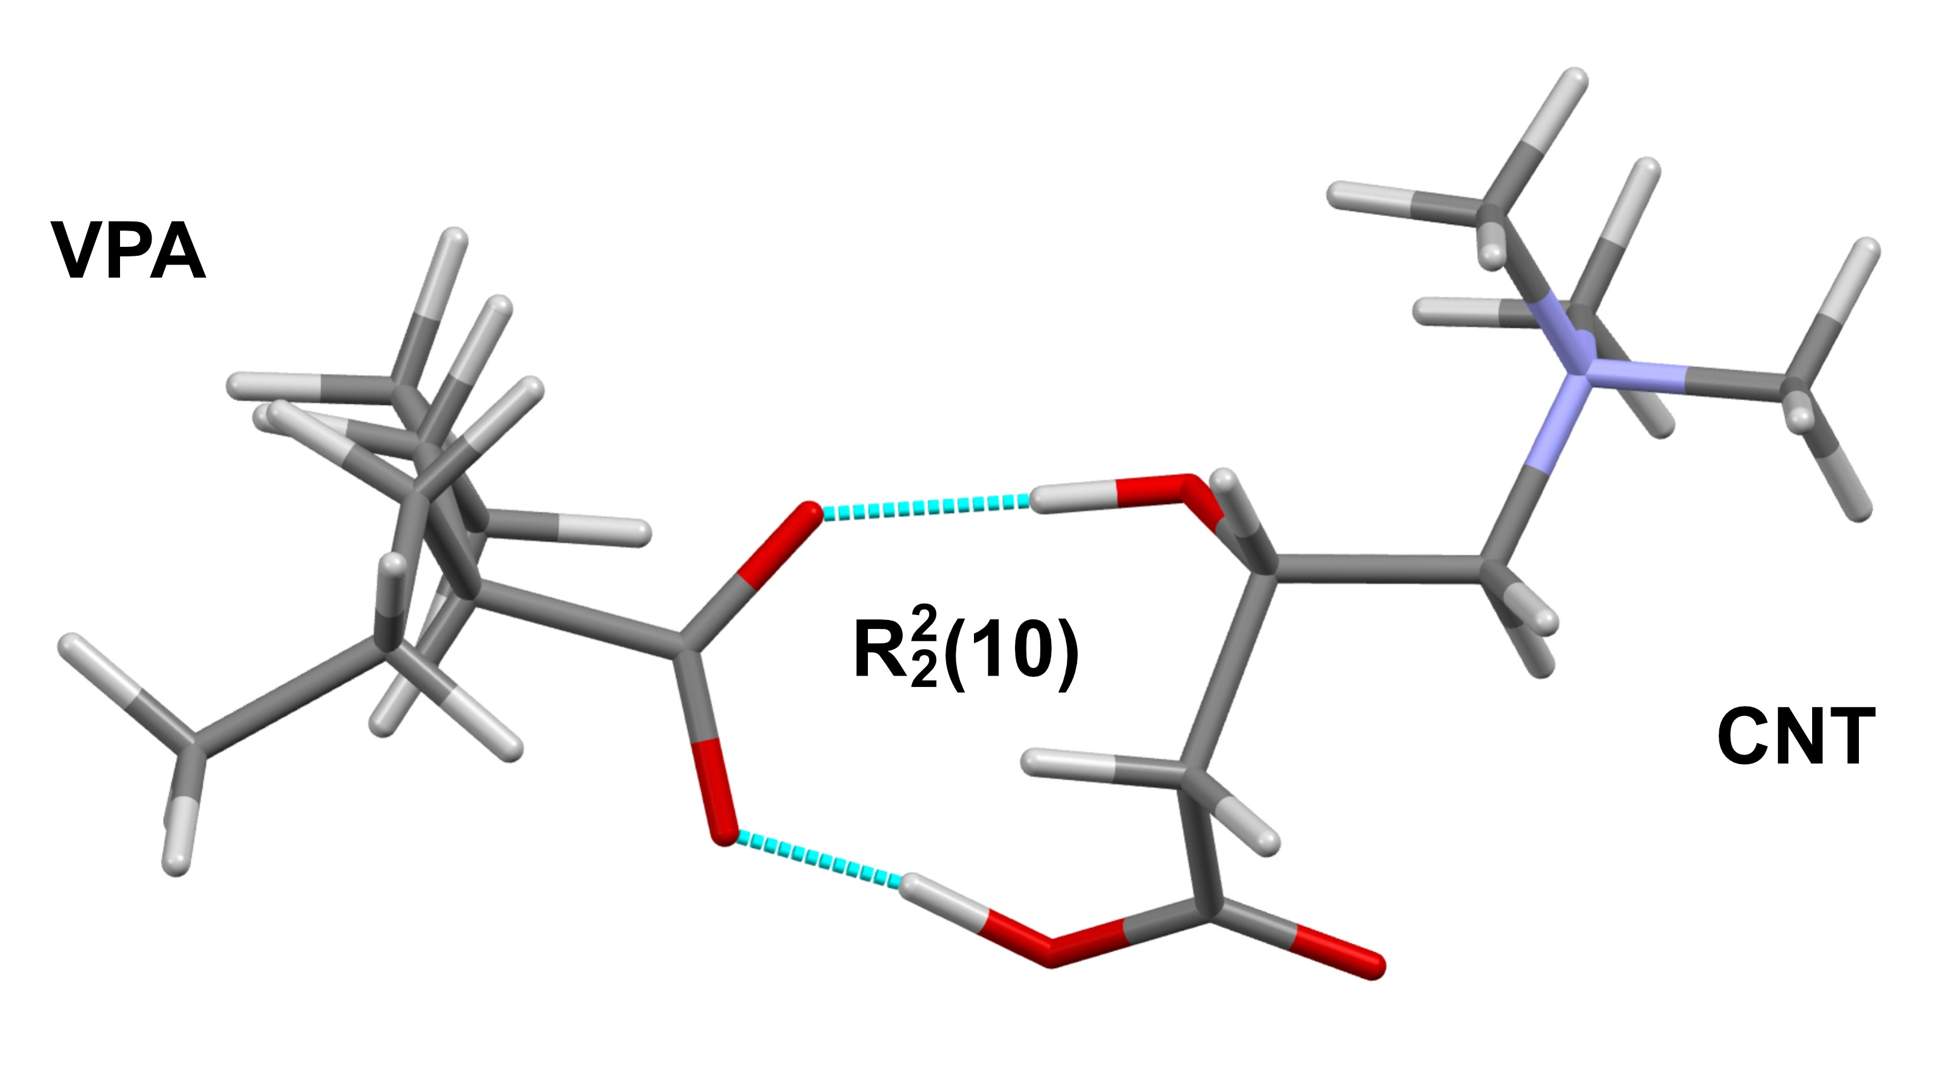

Figure 1. Representation of the asymmetric unit of VPA*CNT and the characteristic $R_{2}^{2}\left(10\right)$ hydrogen-bond motif (turquoise dashed lines).

[1] Lheureux, P. E. R., Hantson, P. (2009). Clin. Toxicol. 47, pp. 101–111.
[2] Bordignon, S., Bravetti, F., Gallo, A., Gobetto, R., Chierotti, M. R. (2023). Co-cristallo farmaco-farmaco di L-carnitina e acido valproico. Patent n. IT 102023000027489.
[3] Harris, K. D. M. (2022). Crystals 12, 1277.

