Interplay between crystal structure and magnetism in Tb₂CoGe₂ upon hydrogenation

N. Saidov¹, K. Miliyanchuk¹, S. Mašková-Černa², L. Havela², R. Gladyshevskii¹

¹Department of Inorganic Chemistry, Ivan Franko National University of Lviv, Kyryla i Mefodiya St. 6, 79005 Lviv, Ukraine,
²Department of Condensed Matter Physics, Charles University, Ke Karlovu 5, 121 16 Prague 2, Czechia

nazar.saidov@lnu.edu.ua
The intermetallic compound Tb₂CoGe₂ adopts the structure type Sc₂CoSi₂ (Pearson symbol mS20, space group C2/m) [1], which belongs to the intergrowth structure series based on CrB- and TiNiSi-type slabs. The representatives of this structure series can be described by the general formula R_{m+n}T_{m}M_{m+n} (R is a rare-earth metal, T is a d-element, M is a main group element, m and n represent the number of TiNiSi and CrB fragments, respectively). In the case of Sc₂CoSi₂-type compounds the ratio m : n = 2 : 2 [2] (Fig. 1a).
The initial intermetallic Tb₂CoGe₂ was synthesized by arc-melting the constituent metals. Hydrogenation of the activated (by heating in vacuum) crushed sample was performed under a hydrogen pressure of 770 mbar. Heating up to 250°C was required to initiate the reaction. The pressure drop in the system corresponded to the hydride composition Tb₂CoGe₂H_{0.9}. Phase analysis and crystal structure determinations were performed by X-ray powder diffraction (Bruker D8 Advance diffractometer, Cu Kα radiation). A SQUID magnetometer (Quantum Design) was used for magnetic measurements in the temperature range 2-300 K and in magnetic fields of up to 7 T.
The refined crystal structure parameters of Tb₂CoGe₂ are close to those reported in [1]: space group C2/m, a = 10.5276(5) Å, b = 4.2062(4) Å, c = 10.1888(5) Å, β = 118.083(2)°, V = 398.05(5) Å³, Tb1 (4i) (0.0078(5) 0 0.3329(4)), Tb2 (4i) (0.1888(4) 0 0.1105(4)), Co (4i) (0.2641(8) 0 0.6425(14)), Ge1 (4i) (0.3464(8) 0 0.4339(8)), Ge2 (4i) (0.4785(8) 0 0.1171(8)). The structure of the metallic matrix is preserved upon hydrogenation: C2/m, a = 10.9455(5) Å, b = 4.1356(2) Å, c = 10.1555(5) Å, β = 119.189(2)°, V = 401.33(4) Å³, Tb1 (4i) (-0.0058(5) 0 0.3197(4)), Tb2 (4i) (0.1893(5) 0 0.0968(5)), Co (4i) (0.2761(11) 0 0.6192(12)), Ge1 (4i) (0.3493(8) 0 0.4285(8)), Ge2 (4i) (0.5064(9) 0 0.1361(8)). Hydrogenation results in a moderate cell volume increase (∆V/V = 0.82 %) caused by lattice expansion in the direction of the a-axis (∆a/a = 3.97 %), partly compensated by lattice contraction in the directions of the b- (∆b/b = -1.68 %) and c-axes (∆c/c = -0.33 %).
Tb₂CoGe₂ exhibits multiple magnetic phase transitions below the ordering temperature T = 130 K (Fig. 1b,c). Based on the shape of the magnetization curve at 2 K, the ground state can be assumed to be ferrimagnetic, while the magnetization curve at 150 K is typical for an approach to antiferromagnetism. Hydrogenation suppresses magnetic interactions in the hydride, which orders magnetically at 25 K. The results will be discussed in terms of different impact of hydrogenation on the environment of Tb atoms in different positions.
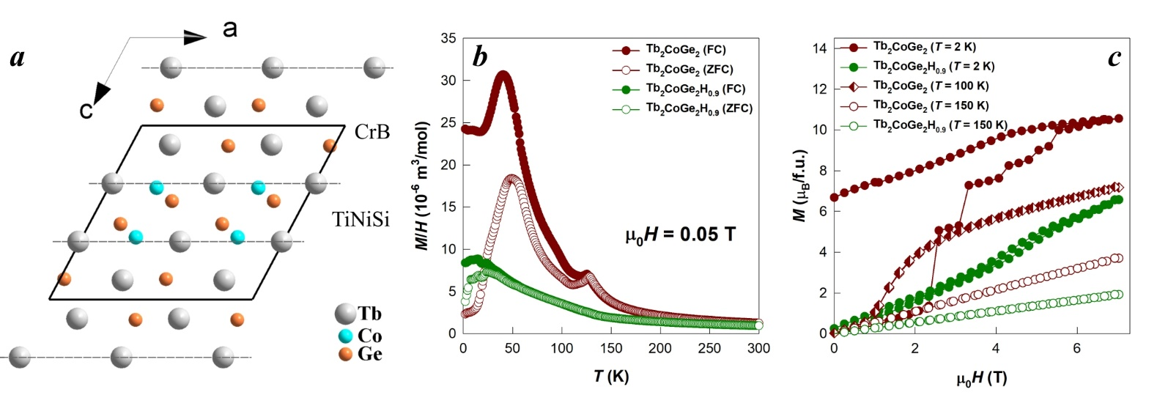

Figure 1. Representation of the crystal structure of Tb₂CoGe₂ as intergrowth of CrB- and TiNiSi-type slabs (a); magnetic susceptibility curves for Tb₂CoGe₂ and Tb₂CoGe₂H_{0.9} measured in field-cooled (FC) and zero-field-cooled (ZFC) mode (b); magnetization curves for Tb₂CoGe₂ and Tb₂CoGe₂H_{0.9} measured at various temperatures (c).

[1] Bodak, O. I., Pecharskii, V. K., Starodub, P. K., Salamakha, P. S., Mrooz, O. Y. & Bruskov, V. A. (1986). Izv. Akad. Nauk SSSR, Met. 4, 216.

[2] Zhao, J. & Parthé, E. (1989). Acta Crystallogr. C 45, 1853.
This work was supported by the Ministry of Education and Science of Ukraine under the grants No. 0124U000989 and No. 0125U000767. N.S. and K.M. thank the Simons Foundation (Award Number: 00014574) for support.

