# VMXi, a fully automated *in-situ* beamline: towards large-scale crystallographic fragment screening at room temperature.

## M. Lambert1, A. Thompson1, H. Mikolajek1, J. Sanchez-Weatherby1, J. Sandy1, M. Hough1

### 1Diamond Light Source, Harwell Science and Innovation Campus, Didcot, Oxfordshire, UK

### [m.lambert@diamond.ac.uk](mailto:m.lambert@diamond.ac.uk)

Fragment-based drug-discovery is considered a powerful approach to drug lead discovery. To facilitate the use of X-Ray Crystallography as a primary screening tool, many synchrotrons have recently developed highly specialised platforms capable of handling high-throughput screening campaigns [1, 2, 3]. At present, a vast majority of these screening campaigns are conducted at cryogenic temperatures. However, growing interest in room-temperature (RT) crystallography as a screening tool could potentially change this. RT crystallography can be used to reveal protein dynamics and may help determine new binding sites and alternative binding poses in protein-ligands systems [4]. As such, results from RT campaigns could be used in addition to results from cryogenic campaigns to get a fuller picture during the drug design process.

To facilitate large-scale crystallographic fragment screening at room temperature at the Diamond Light Source, an experimental pipeline has been developed at the VMXi beamline. The VMXi beamline is a fully automated *in-situ* beamline which offers routine RT data collection using a multi-crystal approach [5]. The beamline is currently capable of collecting up to 250 datasets per hour and can help crystallographers collect data from fragment screens rapidly. Here we present current and future developments for the beamline, from crystal soaking to automatic data collection and data analysis.

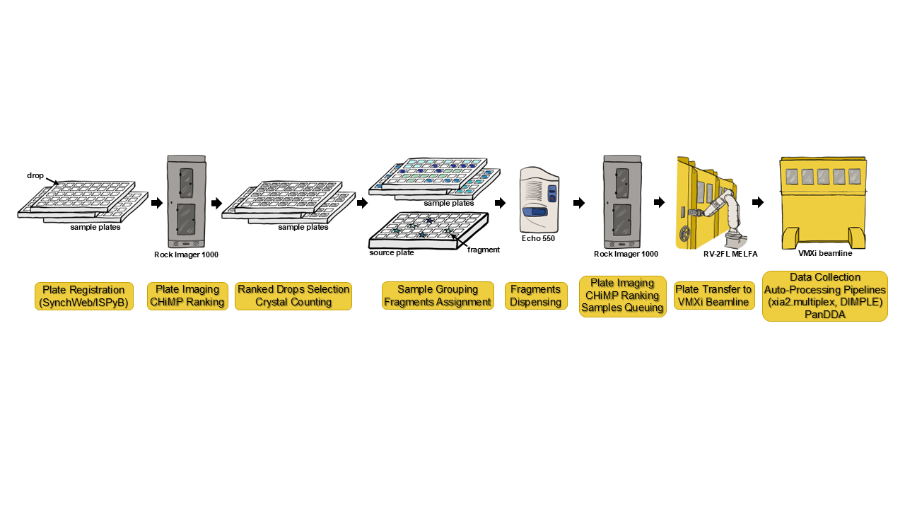

###### **Figure 1**. The VMXi fragment screening pipeline at Diamond Light Source allows for rapid screening with minimal handling. Plates are assessed by CHiMP [6], a deep-learning tool trained to rank drops and find crystals, and compounds are assigned to drops based on the outcome. Once dispensed into, the plates are put back into the imager. A robot arm delivers the plate from the imager to the beamline once samples are queued for data collection by the user.

#### [1] Douangamath, A., Powell, A., Fearon, D., Collins, P. M., Talon, R., Krojer, T., Skyner, R., Brandao-Neto, J., Dunnett, L., Dias, A., Aimon, A., Pearce, N. M., Wild, C., Gorrie-Stone, T., von Delft, F. (2021). *Source. J. Vis. Exp.* **171**, e62414.

#### [2] Lima, G. M. A., Talibov, V. O., Jagudin, E., Sele, C., Nyblom, M., Knecht, W., Logan, D. T., Sjögren, T. & Mueller, U. (2020). *Acta Cryst. D***76**, 771-777.

#### [3] Metz, A., Stegmann, D. P., Panepucci, E. H., Buehlmann, S., Huang, C.-Y., McAuley, K. E., Wang, M., Wojdyla, J. A., Sharpe, M. E. & Smith, K. M. L. (2024). *Acta Cryst. D***80**, 328-335.

#### [4] Skaist Mehlman, T., Biel, J. T., Azeem, S. M., Nelson, E. R., Hossain, S., Dunnett, L., Paterson, N. G., Douangamath, A., Talon, R., Axford, D., Orins, H., von Delft, F., & Keedy, D. A. (2023). *eLife*, **12**, e84632.

#### [5] Sandy, J., Mikolajek, H., Thompson, A. J., Sanchez-Weatherby, J., Hough, M. A. (2024). *Source.* *J. Vis. Exp.* **205**, e65964.

#### [6] King O. N. F., Levik K. E., Sandy J., Basham M. (2024). *bioRxiv.* *05.22.595345.*

The work is supported by the EU project Fragment-Screen, grant agreement ID: 101094131. We thank the XChem team for allowing us to use their facilities and for their assistance throughout the project. We also thank Dr. H. Walters-Morgan, Dr. R. Flaig, Dr. E. Williams & Dr L. Koekemoer for their help with protein production.